**HKU SPACE Community College**

**Associate Degree Programme**

**Second Semester 2023-2024**

# **Project on Knowledge Products Development**

**Project Final Report**

**Project Name: Learning Buddy**

Group 7

Chan Tze Hei, Dawn (20219923)

Lam Tsun Ting, Bryan (20219894)

Lee Pak Lok, Leo (20220728)

Jian Chun Hin, Ben (20207461)

Chau Siu Hong, Joe (20186650)

**Abstract**

Our project name is Learning Buddy, which is a java software. This project aims to provide a learning tool to help users acquire the new knowledge successfully. Therefore, in this final report, we will discuss our product in different sections. There are project description, project objective, development process, literature (or existing solution) review, design, methodology and implementation section, schedule, resource allocation, discussion, conclusion, recommendation, future scope, individual progress and references.

In the project description, project objective and development process, the project content and project objective will be illustrated simply. For the development, the details of the development schedule will be shown.

In addition, about the literature(existing solution) review, it is a section for us to compare our product and the market product. You can easily find out the disadvantages and advantages of our product.

Besides, in the design, methodology and implementation section, we will explain all the design and the detail of our functions. All the functions would be discussed with screenshots.

Moreover, in the schedule, resource allocation and individual progress part, all the schedule of the meetings will be shown to enhance the understanding of our development progress. Also, we also write down the simple resource allocation of our project, if you want further information, the individual progress part can be referenced to acquire detailed human resource allocation.

Finally, in the discussion, conclusion, recommendation and future scope, we will talk about some difficulties we meet in this project and discuss the solutions. After that, there is a short conclusion of the report and product content. Lastly, there is the recommendation and future scope: the recommendation includes the available update of our product; the future scope includes the further update but not available for our product.

**Table of Contents**

| **Abstract** | P.2 |
| --- | --- |
| **Table of Contents** | P.3 |
| **List of Figures** | P.4-6 |
| **List of Table** | P.7 |
| **Introduction(Project Description, Project Objective, Development Process )** | P.8-12 |
| **Literature (or Existing Solution) Review** | P.13 |
| **Design** | P.14-23 |
| **Methodology and Implementation** | P.24-37 |
| **Schedule and Resources Allocation** | P.38-41 |
| **Discussion** | P.42 |
| **Conclusion and Recommendation** | P.43 |
| **Future Scope** | P.43 |
| **Individual Progress** | P.44 |
| **References** | P.45 |
| **Appendies** | P.46 |

**List of figures**

| Figure: | Pages: |
| --- | --- |
| Figure 3.1.1 | 14 |
| Figure 3.1.2 | 14 |
| Figure 3.1.3 | 14 |
| Figure 3.1.4 | 15 |
| Figure 3.1.5 | 15 |
| Figure 3.1.6 | 15 |
| Figure 3.1.7 | 15 |
| Figure 3.1.8 | 16 |
| Figure 3.1.9 | 16 |
| Figure 3.1.10 | 16 |
| Figure 3.1.11 | 17 |
| Figure 3.1.12 | 17 |
| Figure 3.1.13 | 17 |
| Figure 3.2.1 | 18 |
| Figure 3.2.2 | 18 |
| Figure 3.2.3 | 18 |
| Figure 3.2.4 | 18 |
| Figure 3.2.5 | 18 |
| Figure 3.2.6 | 19 |
| Figure 3.2.7 | 20 |
| Figure 3.2.8 | 20 |
| Figure 3.2.9 | 20 |
| Figure 3.2.10 | 21 |
| Figure 3.2.11 | 21 |
| Figure 3.2.12 | 22 |
| Figure 3.2.13 | 22 |
| Figure 3.2.14 | 22 |
| Figure 3.2.15 | 22 |
| Figure 3.2.16 | 23 |
| Figure 4.1 | 24 |
| Figure 4.2 | 24 |
| Figure 4.3 | 25 |
| Figure 4.4 | 25 |
| Figure 4.5 | 26 |
| Figure 4.6 | 27 |
| Figure 4.7 | 27 |
| Figure 4.8 | 28 |
| Figure 4.9 | 28 |
| Figure 4.10 | 28 |
| Figure 4.11 | 29 |
| Figure 4.12 | 29 |
| Figure 4.13 | 30 |
| Figure 4.14 | 30 |
| Figure 4.15 | 30 |
| Figure 4.16 | 31 |
| Figure 4.17 | 31 |
| Figure 4.18 | 31 |
| Figure 4.19 | 32 |
| Figure 4.20 | 33 |
| Figure 4.21 | 33 |
| Figure 4.22 | 34 |
| Figure 4.23 | 34 |
| Figure 4.24 | 34 |
| Figure 4.25 | 35 |
| Figure 4.26 | 35 |
| Figure 4.27 | 36 |
| Figure 4.28 | 36 |
| Figure 4.29 | 37 |

**List of tables**

| **Table Name:** | **Page:** |
| --- | --- |
| **Table 1: Timeline of schedule** | **P.9** |
| **Table 2 Meeting Schedule** | **P.31** |
| **Table 3 Resource Allocation** | **P.34** |
| **Table 4 Individual progress** | **P.37** |
|  |  |
|  |  |
|  |  |
|  |  |
|  |  |
|  |  |
|  |  |
|  |  |
|  |  |
|  |  |
|  |  |
|  |  |
|  |  |
|  |  |
|  |  |

**1. Introduction**

**1.1 Project Description**

In our program, there are five main parts, they are……

* Training
* Reminder
* Achievement
* Document Management
* Login & Learning_Buddy main page

First, as for the **Login & Learning_Buddy main page**. Login page is the starting page. Users need to login his/her account or create his/her own user account. After that, the user will enter the Learning_Buddy main page.

In this page, the user can jump to different functions, such as Training, Reminder, Achievement and Document Management.

In **Training**, it can help users to learn new knowledge and generate a quiz for him/her to do, making sure that the user can acquire the knowledge successfully. In this process, the program will search the information from Wikipedia according to the keywords from users input. After the program catches the data, the program will utilize the question module to create some questions for users.

In **Reminder**, we considered utilizing the Bookmarks to represent the reminder. In this function, users can create bookmarks in this function to jot down the important event or plan with a setting of date and read the created plans though a calendar.

In **Achievement**, this function is used for motivating the user to study. In this function, there are 4 basic achievements in total. They all have advanced stages waiting for users to unlock. In the Achievement GUI, when certain requirements are fulfilled, corresponding achievements will be unlocked for users. They will be shown in a Jtextarea. Also, there is a “Refresh and Save” button provided for users to press. When the button is pressed, a txt file will be created in the desktop of users. It increases the convenience of users to check out their unlocked achievements as they need not open “Learning Buddy” to check them.

Finally, regarding **Document Management**, it provided four functions, including notes importing with files converting, notes grouping, notes and group property editing. The above functions can provide a document management function to help users easily manage his/her study information(file).

**1.2 Project Objectives**

The objective of this project is to develop a software which helps students increase their learning efficiency. In recent years, due to the pandemic, schools were suspended and students need to study online. Under this situation, digital devices are broadly used by students and teachers in order to send and receive learning material such as course notes, avoiding face to face classes at school. After the pandemic, eLearning did not fade out but continued growing as the hardware requirement became lower and related software tools were developed.

However, we have found limitations in the existing learning tools. For example, SOUL system does not have the ability to manage notes or import custom notes. Therefore, We decided to develop an integrated software called “Learning Buddy” which is a more customized learning software to use with personal learning progress.

“Learning Buddy” has different useful functions combined in one single software which is convenient for users, they don’t need to open different softwares to use different functions. For example, we have document management and training in “Learning Buddy”. Users can import their notes or learning materials into “Learning Buddy” to read and after revision, they can use the training function to consolidate the knowledge without switching to another software to save the time for more consolidation. It results in better time management and increases learning efficiency.

**1.3 Description of the whole Development Process**

As for the initial preparation, from 10-9-2023 to 15-11-2023, we discussed the functions of the Learning Buddy which are about motivation and productivity.

Regarding the motivation part, there were three functions which were reminder, timer and achievement functions. We hope those functions can fulfill our user motivation demand

On the other hand, for the productivity part, it has PDF reader, document management, training, translation and calculator functions. After multiple discussions, we decided to cut out some functions which are timer, translation, calculator and PDF reader. It is because these three functions are less important when compared to the remaining functions. They may not increase students’ study efficiency and provide us more time to complete important functions.

In early December 2023, we finalized the functions of the Learning Buddy which are Login and main page. It was the period when we began to write the code.

In the function development primary period, from 1-1-2024 to 27-1-2024. We started to develop different functions which are training, Reminder, Achievement and Achievement.

In the middle of the development period, we made more details for the functions, such as changing the design of functions, adding new ideas, and designing some algorithms to do the data clearing and question making part.

In the first check period, in order to show the demo, we try to debug our demo.

(Febrary 2024)

After that, it was the function developing completed period, from 23-2-2024 to 10-4-2024, the training function and reminder function were completed.

Lastly, from 10-4-2024 to 27-4-2024, we designed the second GUI of our program. Apart from it, all the functions were completed. Namely, we were successful in finishing our project on 27-4-2024.

**1.4 Timeline**

**Table 1: Timeline of schedule**

| Period | From | To | Work | Describe |
| --- | --- | --- | --- | --- |
| Initially Preparation | **10-9-2023** | **15-11-2023** | -Creating an account in GitHub  -Discussing the development plan of the project  -Find some resources and learn some knowledge about java | We discuss some ideas about the project  **Productivity:**   1. **PDF Reader** 2. **Document Management** 3. **Training** 4. **Translation** 5. **Calculator** 6. **Reminder** 7. **Timer** 8. **Achievement** |
| Starting to Wrote the program[basic] | **15-11-2023** | **30-12-2023** | -Developing the Login.java and Learner_Buddy.java |  |
| Developing the function[Primary  period] | **1-14-2024** | **27-1-2024** | -Wiki_2.py + Wiki_2.exe [2024/1/14]  -Storage.java + update Learning_Buddy.java and Login.java[2024/1/15]  -Training.java + Training[Sample].java  -Reminder.java [2024/1/20] | -Try to write the functions. |
| Middle Development | **28-1-2024** | **20-2-2024** | -QuestionMaking.java +  Wiki_3.py + Wiki_3.exe  -Stoplist.txt + QuestionFile.txt  -LearnCalendar.java [2024/2/15] | Write more detail for the function |
| First Check | 21-2-2024 | 22-2-2024 | -Check all the java file, try to run it and found out the bug. | Try to debug |
| Completed the Function | 23-2-2024 | 10-4-2024 | -Finishing the coding part of the Training function.  -Finishing the coding part of the Reminder function. |  |
| Second GUI design | 10-4-2024 | 27-4-2024 | Create a new GUI of the Login page and Main page | Rewrite all the GUI code and use Apache NetBeans IDE 20 to design.  -Completed all the work |

**2. Literature Review**

**Learning Buddy & Duolingo:**

**Duolingo:** [**https://www.duolingo.com/info**](https://www.duolingo.com/info)

**Feature 1: Efficiency**

Users can utilize Duolingo through different patterns. For instance, Mobile Application and Website.

Learning Buddy’s environment only supports the Window System.

**Feature 2: Field**

Duolingo just focuses on the language field but Learning Buddy doesn’t have any limit. It is based on user’s demand and Wikipedia. If you want to learn new things, such as history, science, technology and languages. Learning Buddy can provide a variety of information quickly from Wikipedia and create a quiz to help users to consolidate new-learnt knowledge.

**Feature 3: Reward System**

Duolingo’s reward system is mainly about rewarding extra “Heart” or “Gems” for the user, which means extra study chance. They also have a “Level” system to let users compete with users around the world.

Learning Buddy has an achievement system, which can encourage users to keep using our product when they unlock different achievements.

**Feature 4: Document Management**

Learning Buddy allows users to import their documents and sort them in order, which can encourage users to utilize our program Duolingo does not have this feature.

**3. Design, Methodology and Implementation**

**3.1 Concept/ First Design Idea:**

“Learning Buddy” is a study software for teenagers, so we decided to make it modern and less complicated to let users utilize it conveniently.

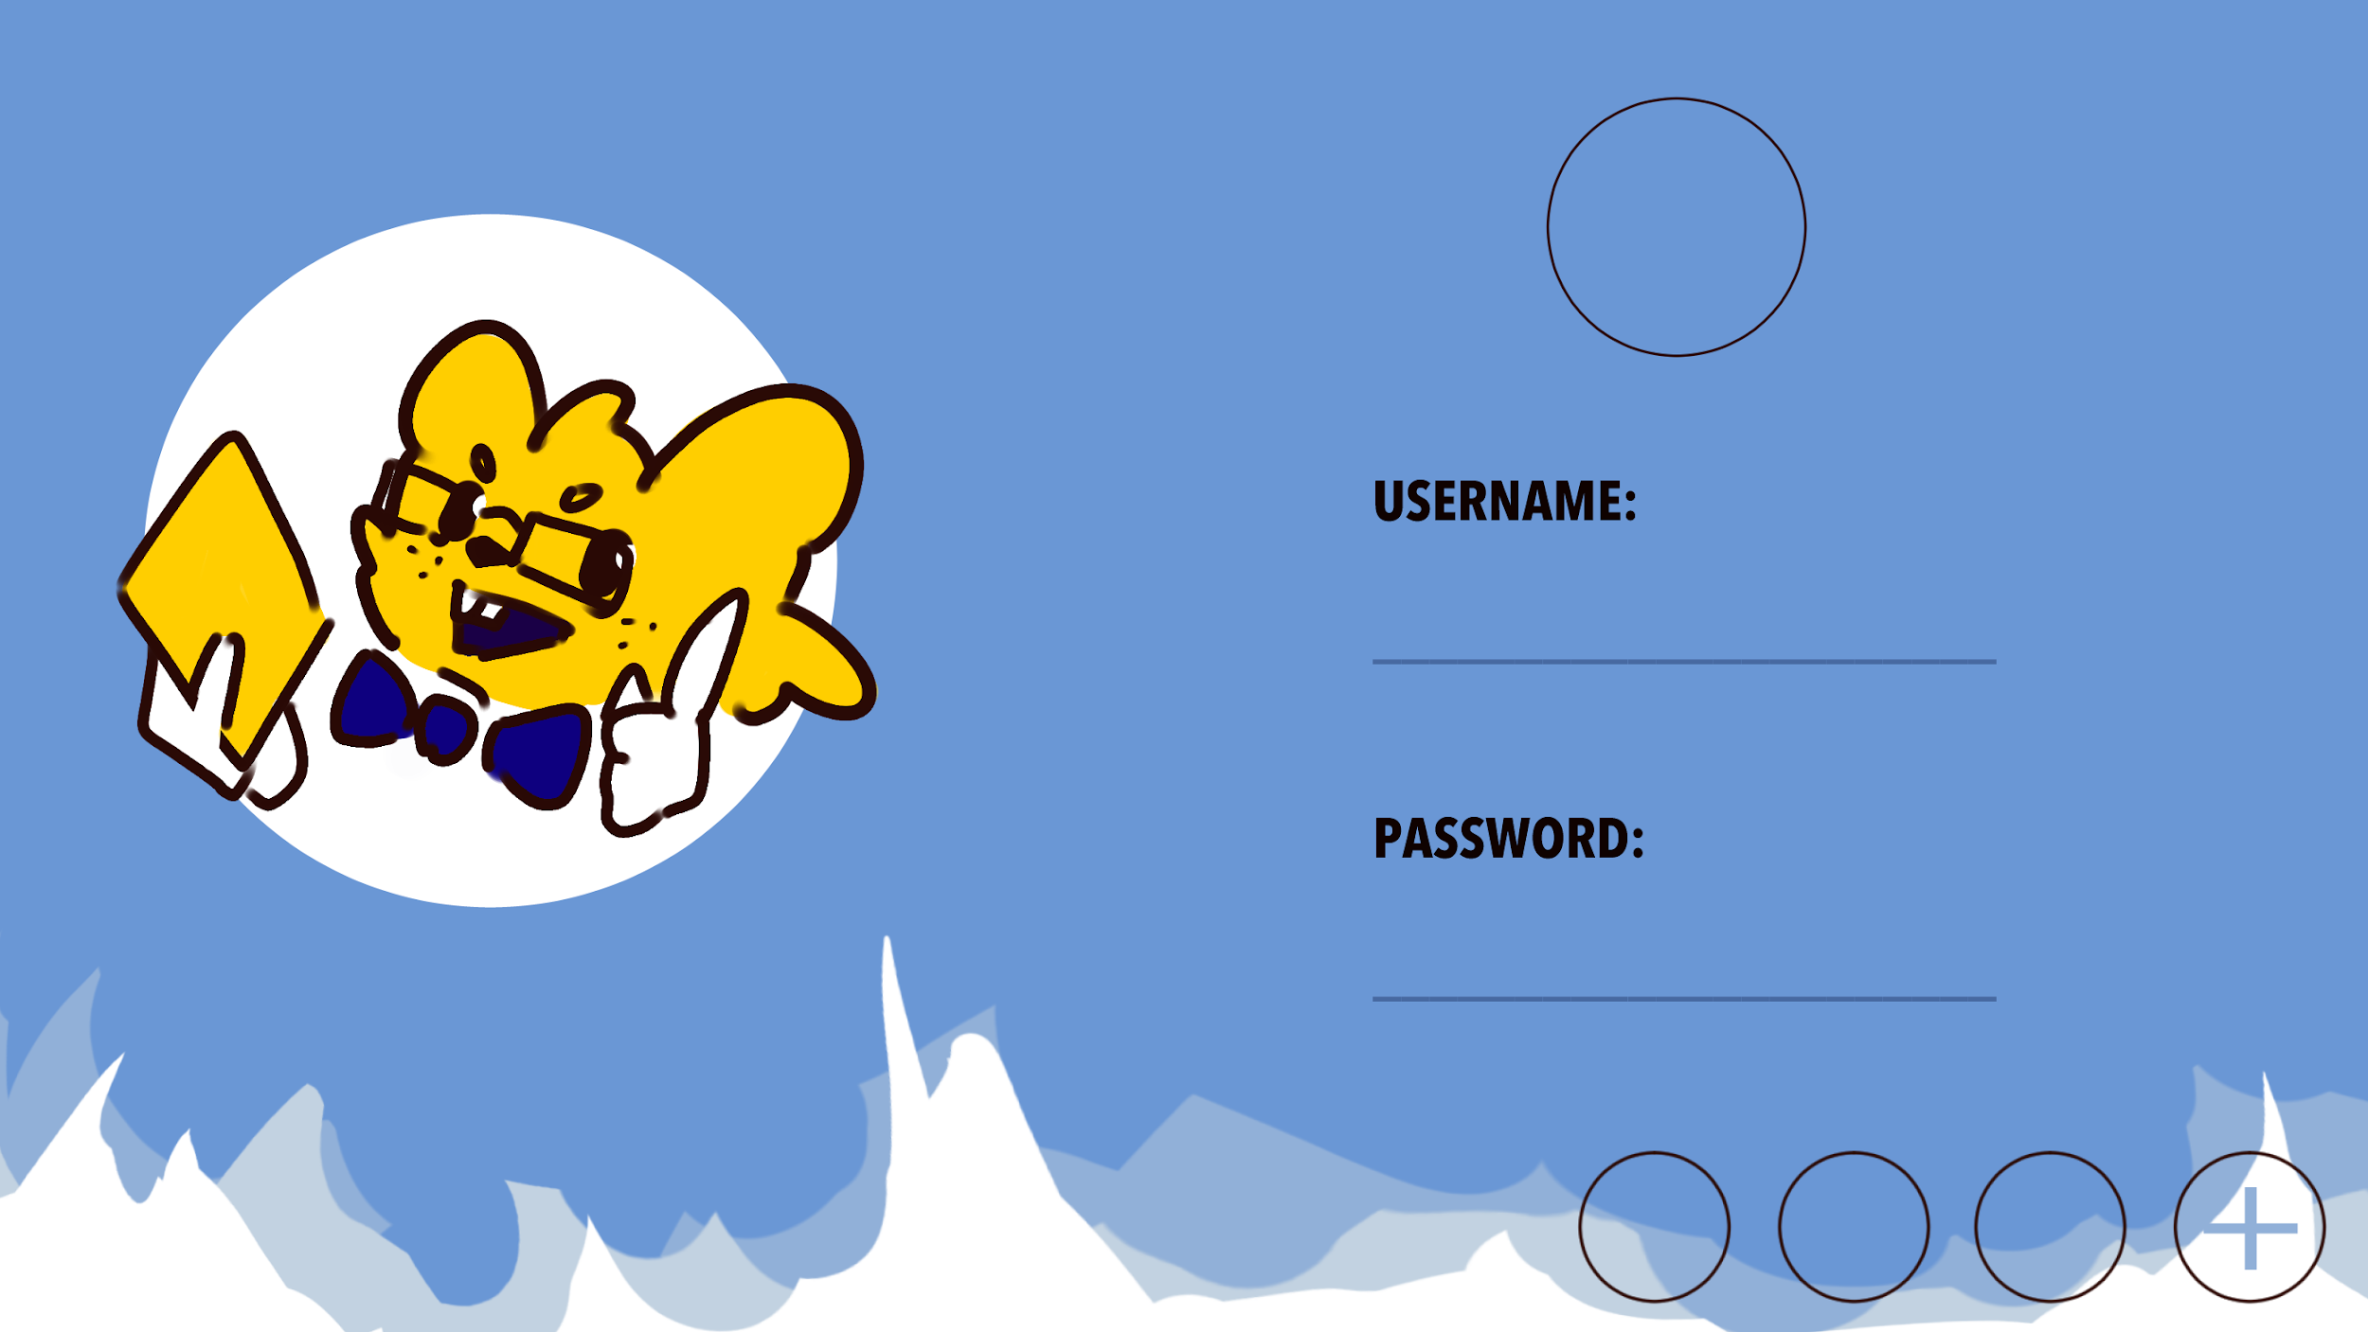**User Interface** is designed in 16:9 size. Everytime the users open “Learning Buddy”, it will first show the **Login** part for the user to choose which account to access. Users are able to create new accounts and switch between different accounts. Image that shows on the right is a concept for this part. Each account contains data separately. (Figure 3.1.1: LoginUI) Figure 3.1.1

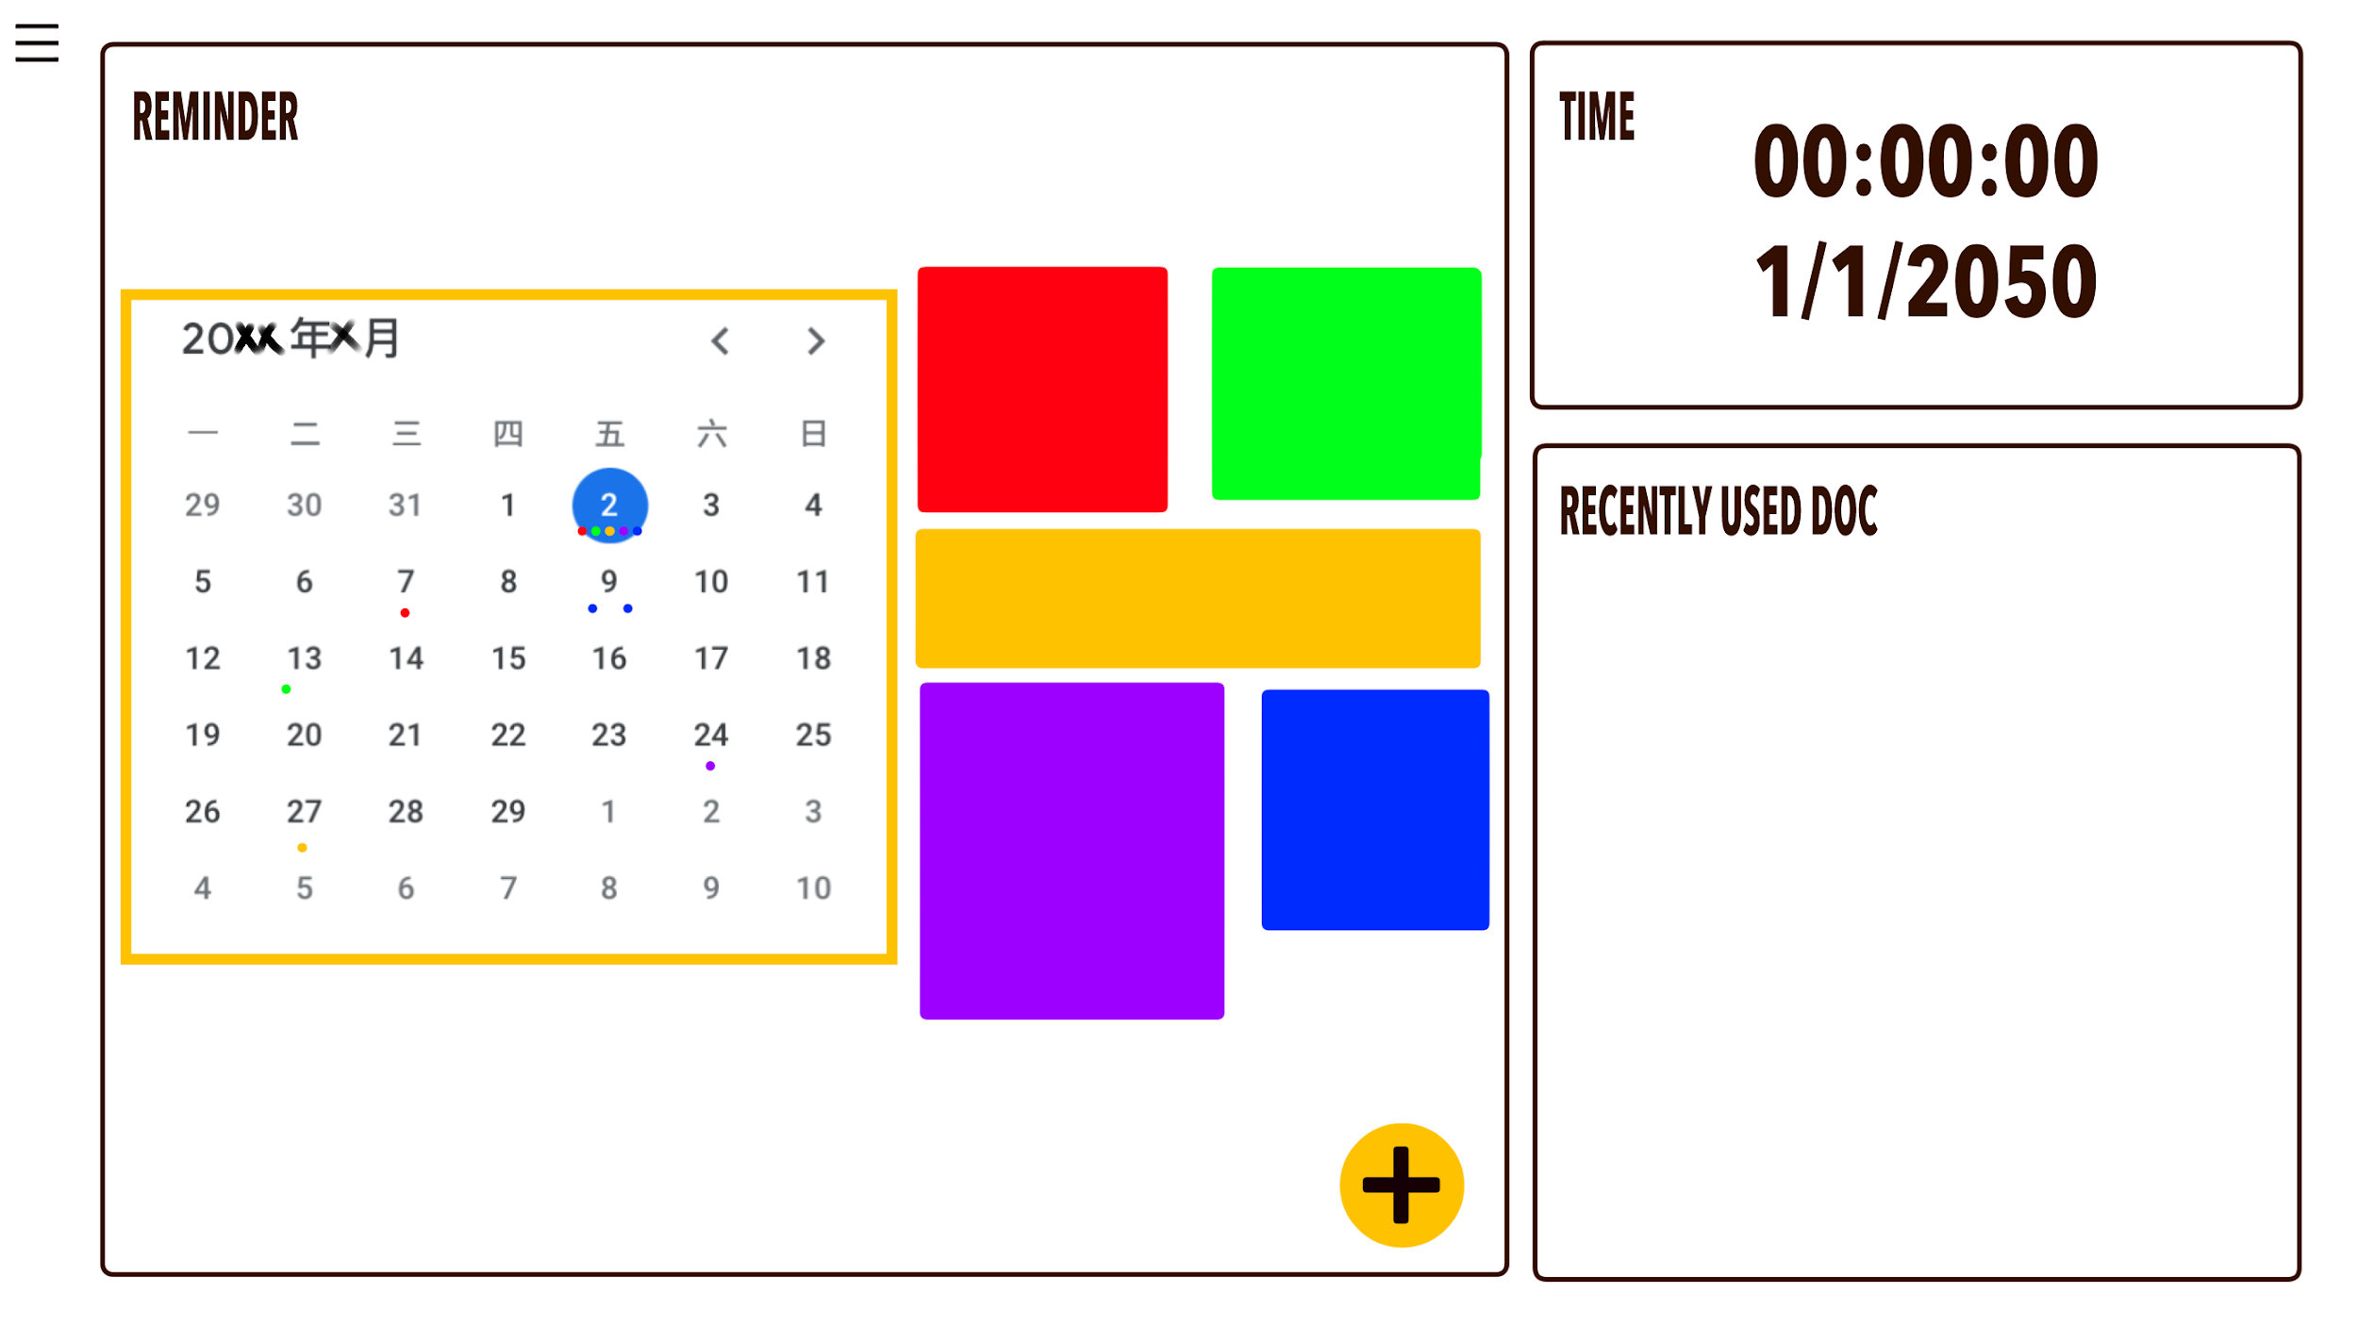

Figure 3.1.2

Once the users login to one account, they will access that account's personal **Main** page. This page has a menu to access our functions.

Clicking the button on the top-left corner, users can open a menu to access 4 functions: “Training”, “Reminder”, “Achievement” and “Document Management”, also switching accounts.

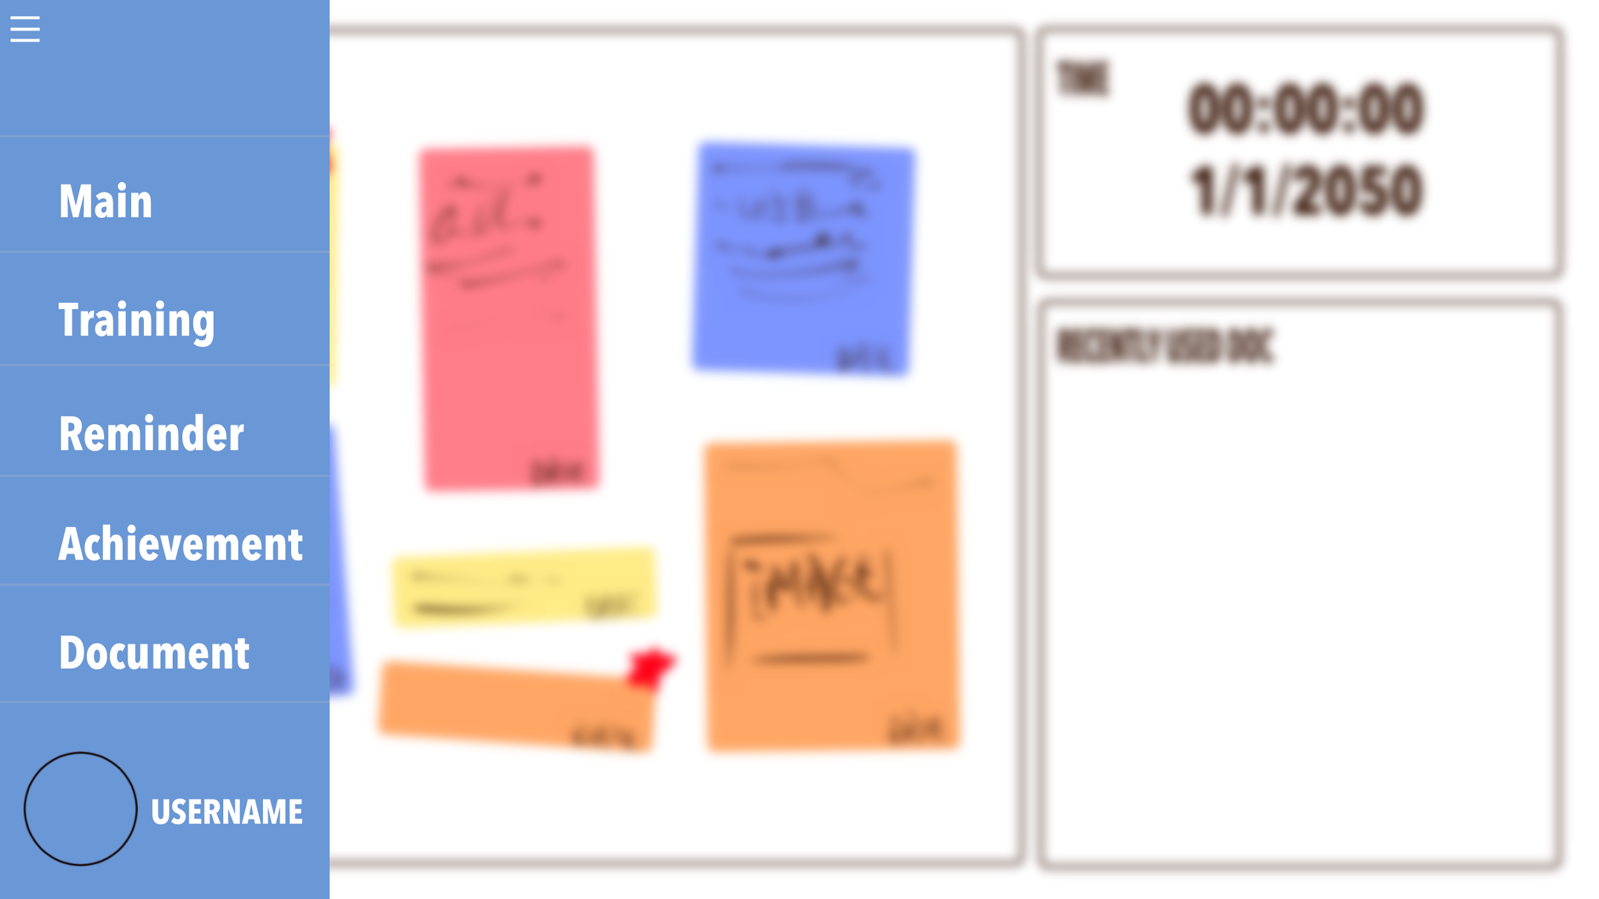

Figure 3.1.3

In “Document Management”, users can view and switch between multiple files at the same time with the tab function. 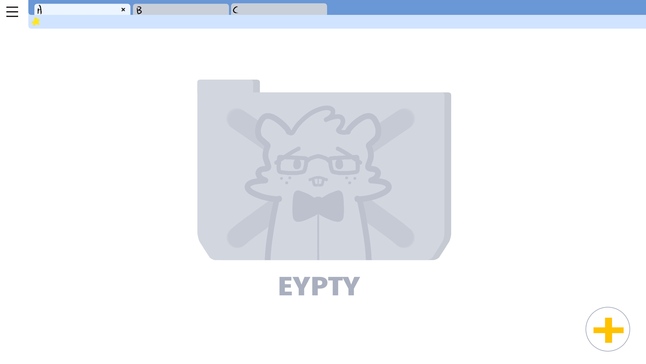

Figure 3.1.4

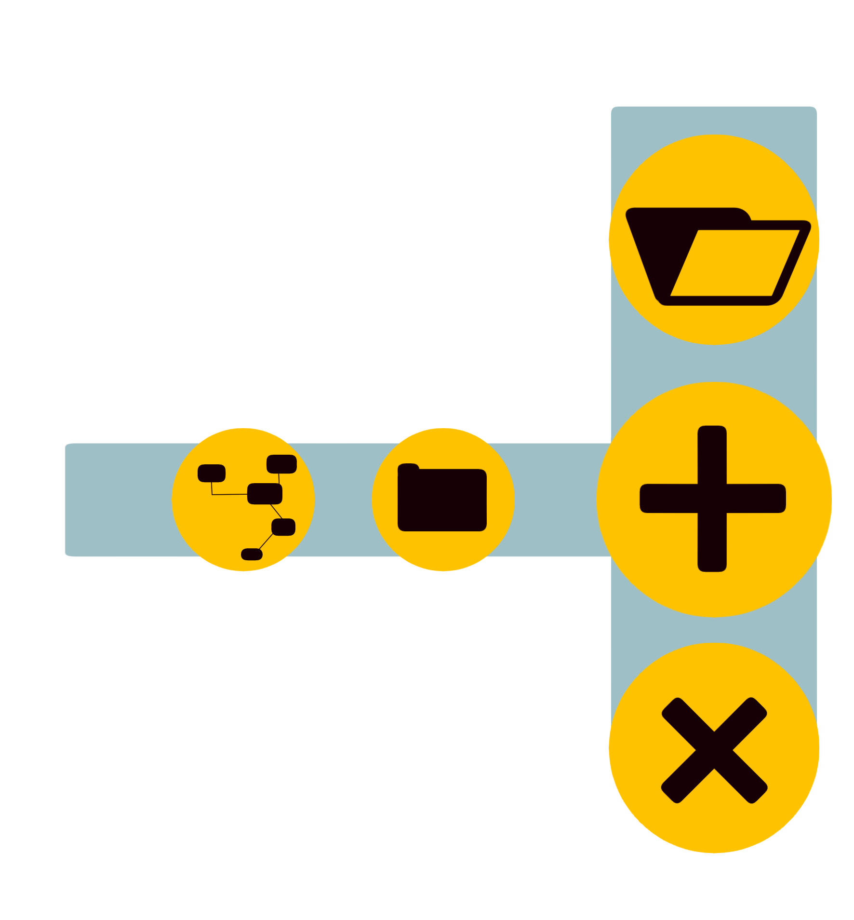

In the bottom right corner, there is a menu which allows users to import notes to the learning buddy or return to the document explorer view.

Figure 3.1.5

Also, users can access file grouping function, file/folder property setting function and file converter from the menu. 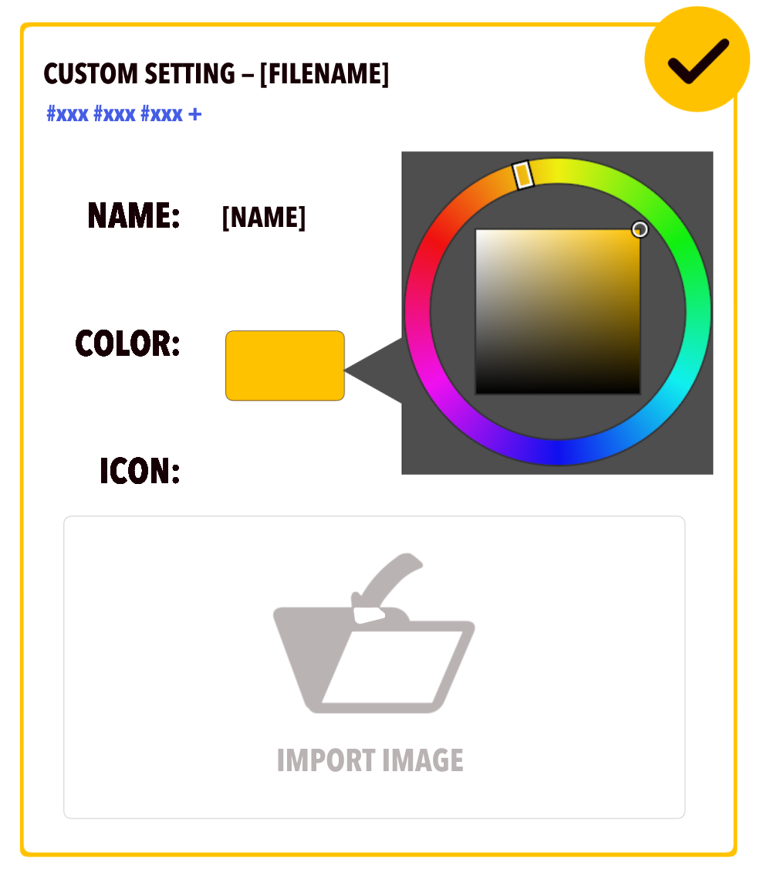

Figure 3.1.6

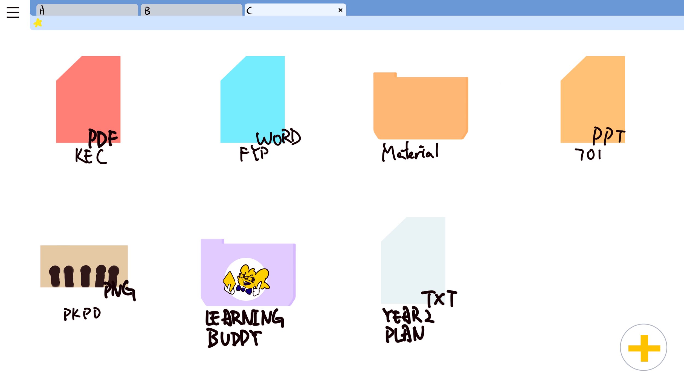

In a new tab page, all the files and folders will be shown in the main window with the colour set in the property setting function.

Figure 3.1.7

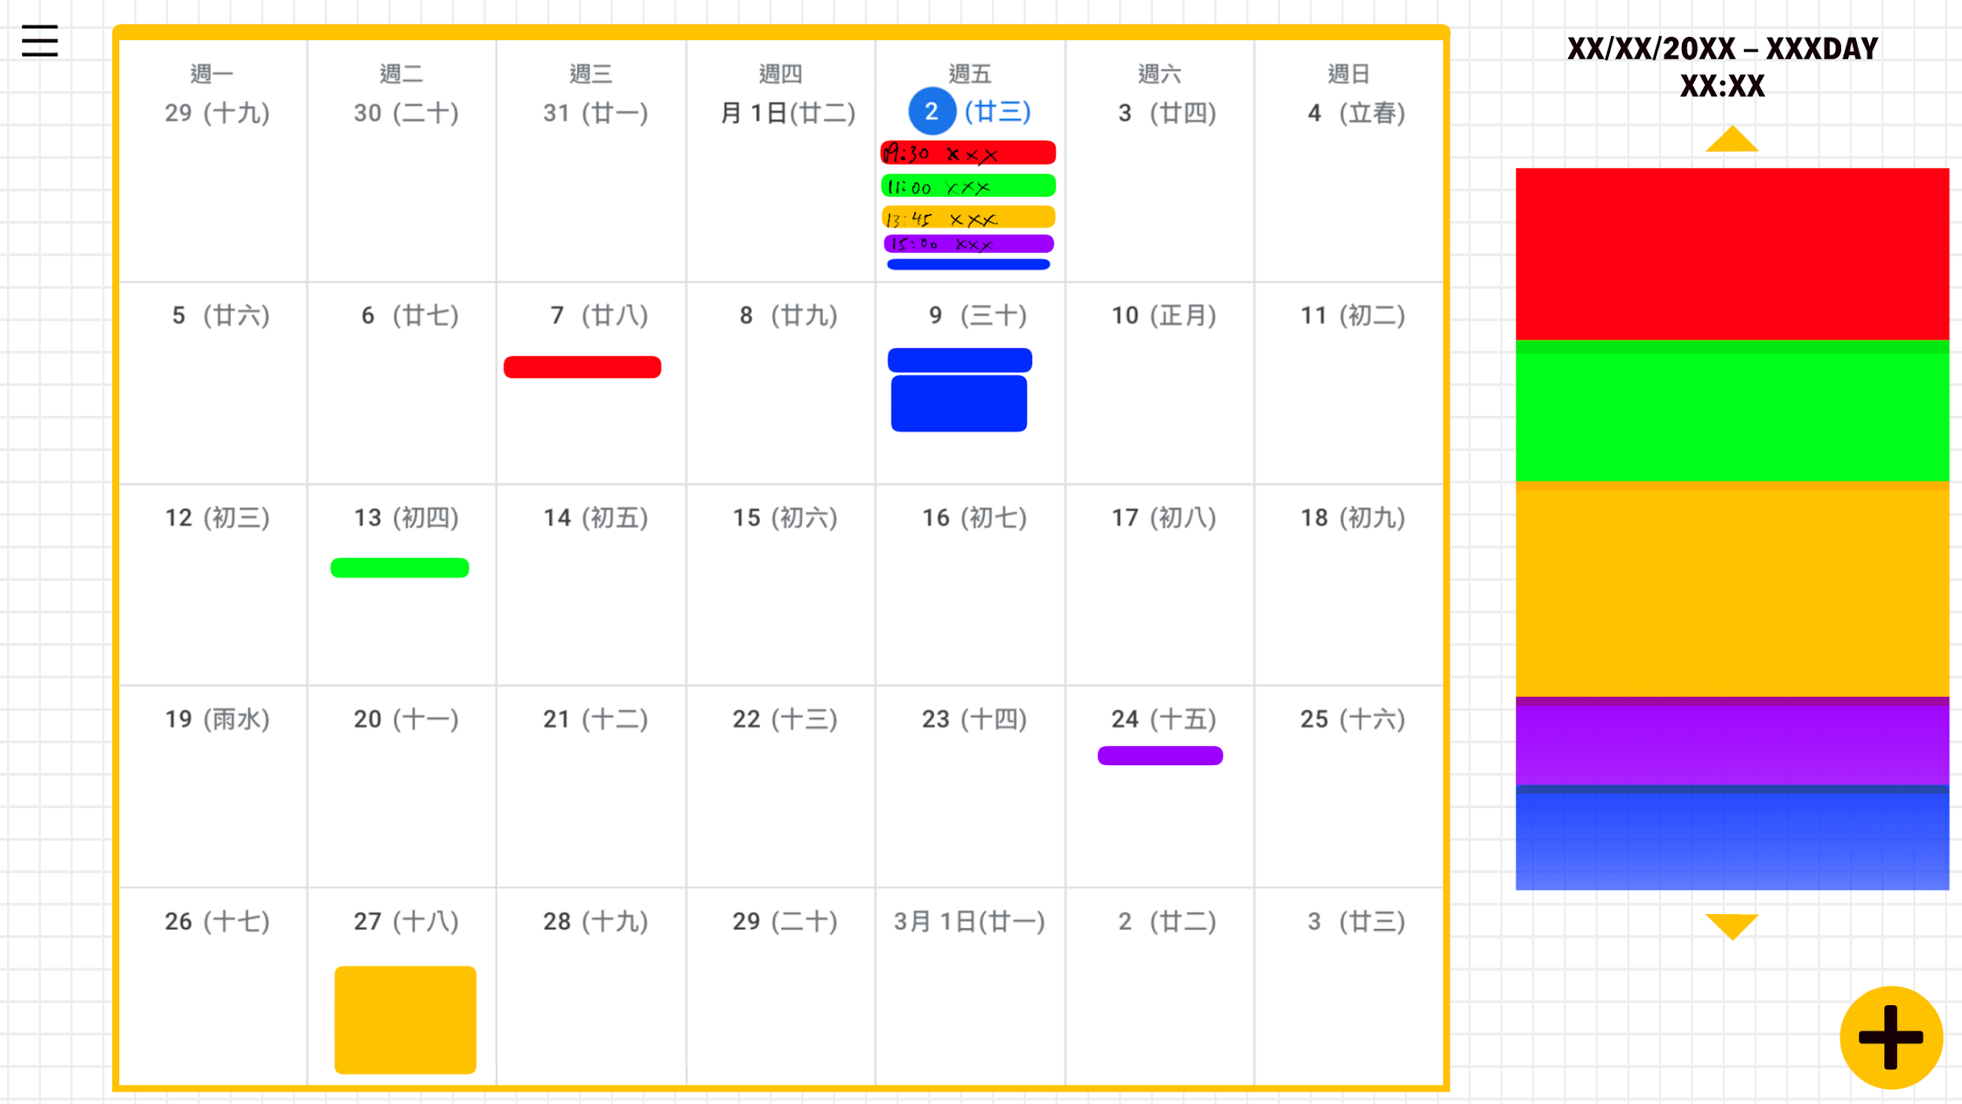

In “Reminder”, users can create a bookmark which includes their study target and expected time by using the button in the right bottom corner.

Figure 3.1.8

Also, They can read the created bookmark in the reminder page. There will be a calendar showing the assigned plan.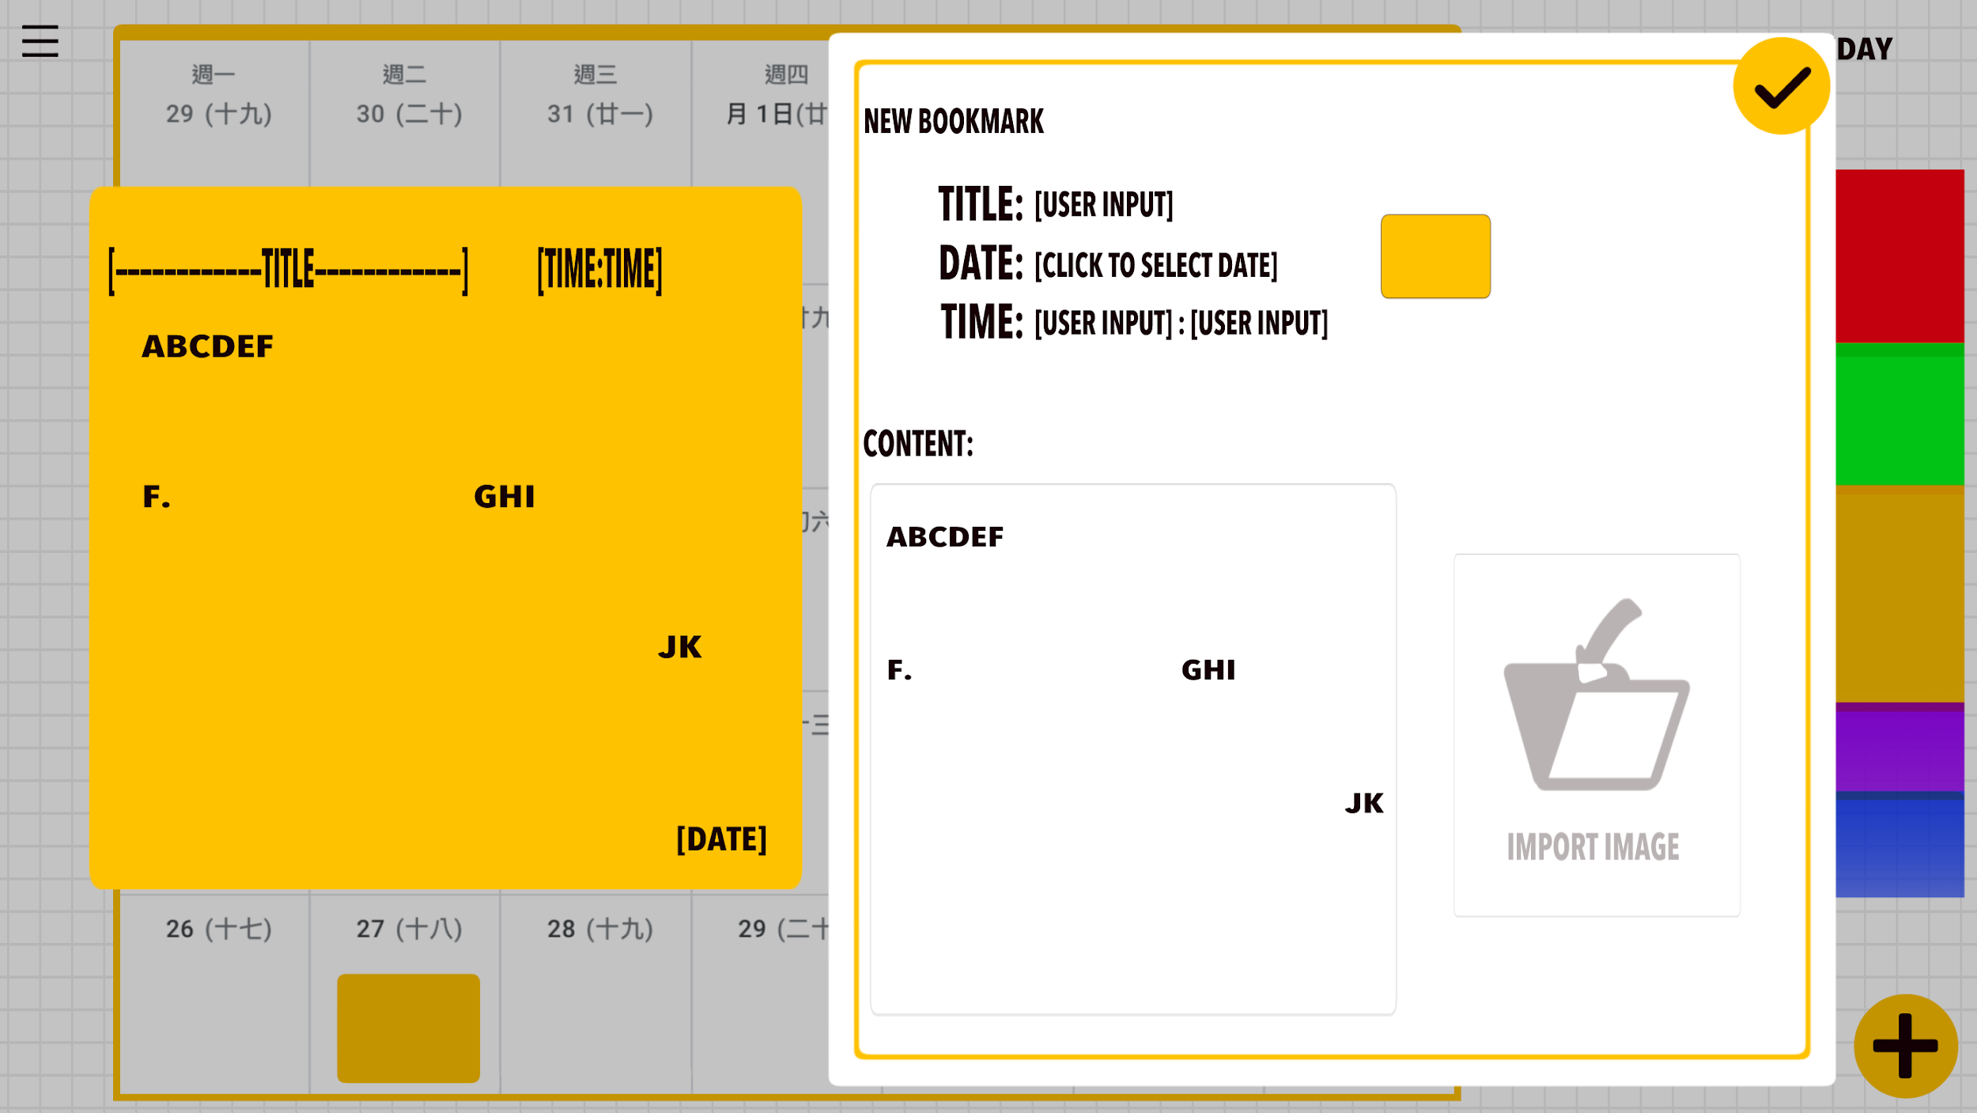

Figure 3.1.9

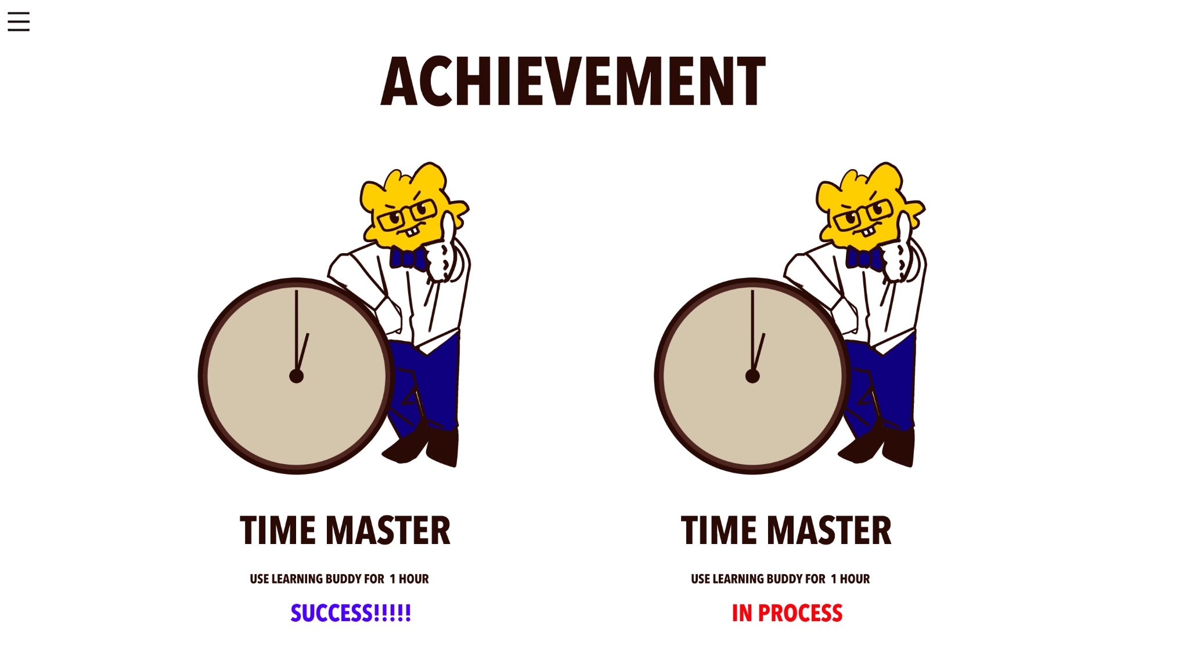

In the function “Achievement”, there are five achievements created and waiting for users to unlock. The first is “ClickMaster” which can be unlocked after clicking the mouse cursor for 1000 times. The above achievement has a second stage, which is called “ClickMaster II”. It can be unlocked by further clicking the mouse

cursor for 200 times. The remaining three

achievements are “10 Questions!!!”,

“1 Reminder!!!” and “10 Documents!!!”. Figure 3.1.10

They can be unlocked by answering 10

questions, creating 1 reminder and

importing 10 documents. Users can see their

unlocked achievements in the GUI and also a

“Refresh and Save” button is provided for users to

refresh their unlocked achievements and save them

into a txt file. Users can check on the txt file

whenever they like without opening Learning Buddy.

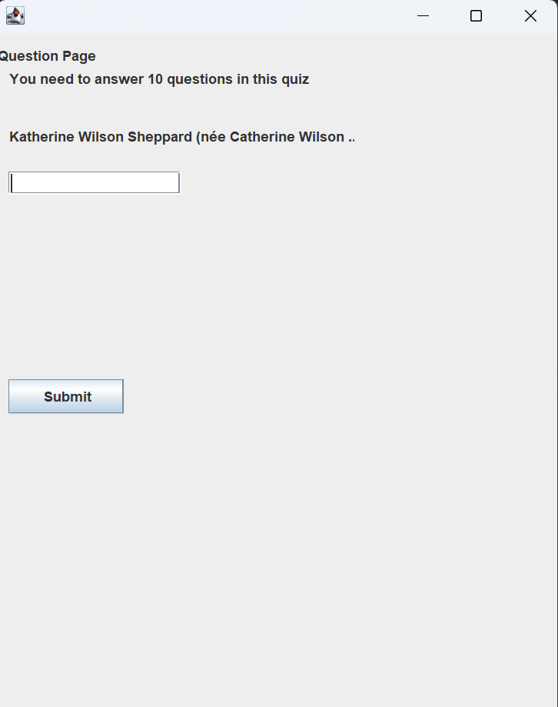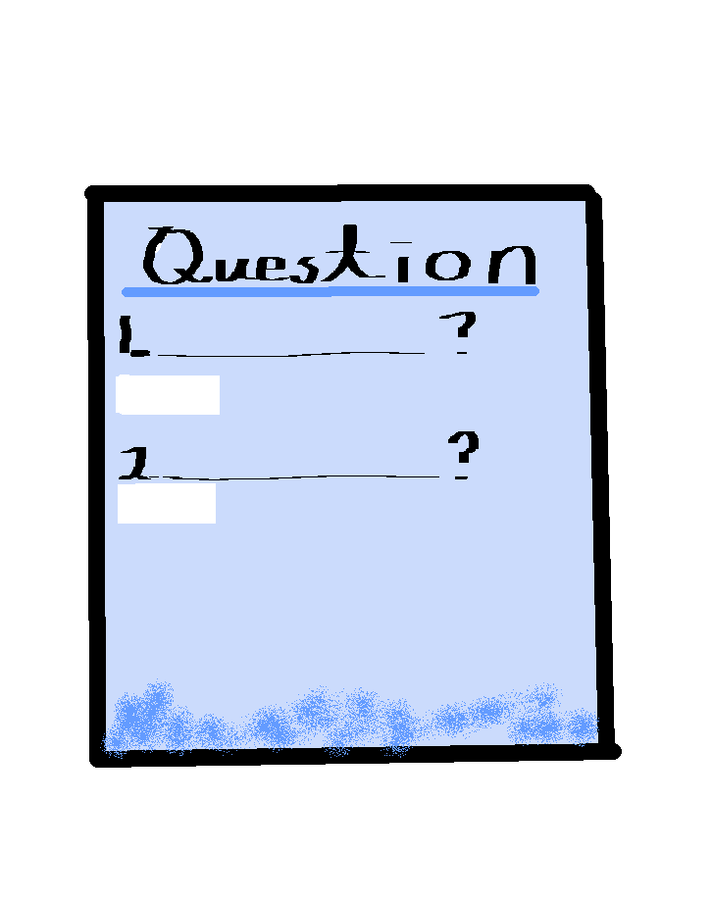

Figure 3.1.11 Figure 3.1.12

**A design of QuestionMaking Part.**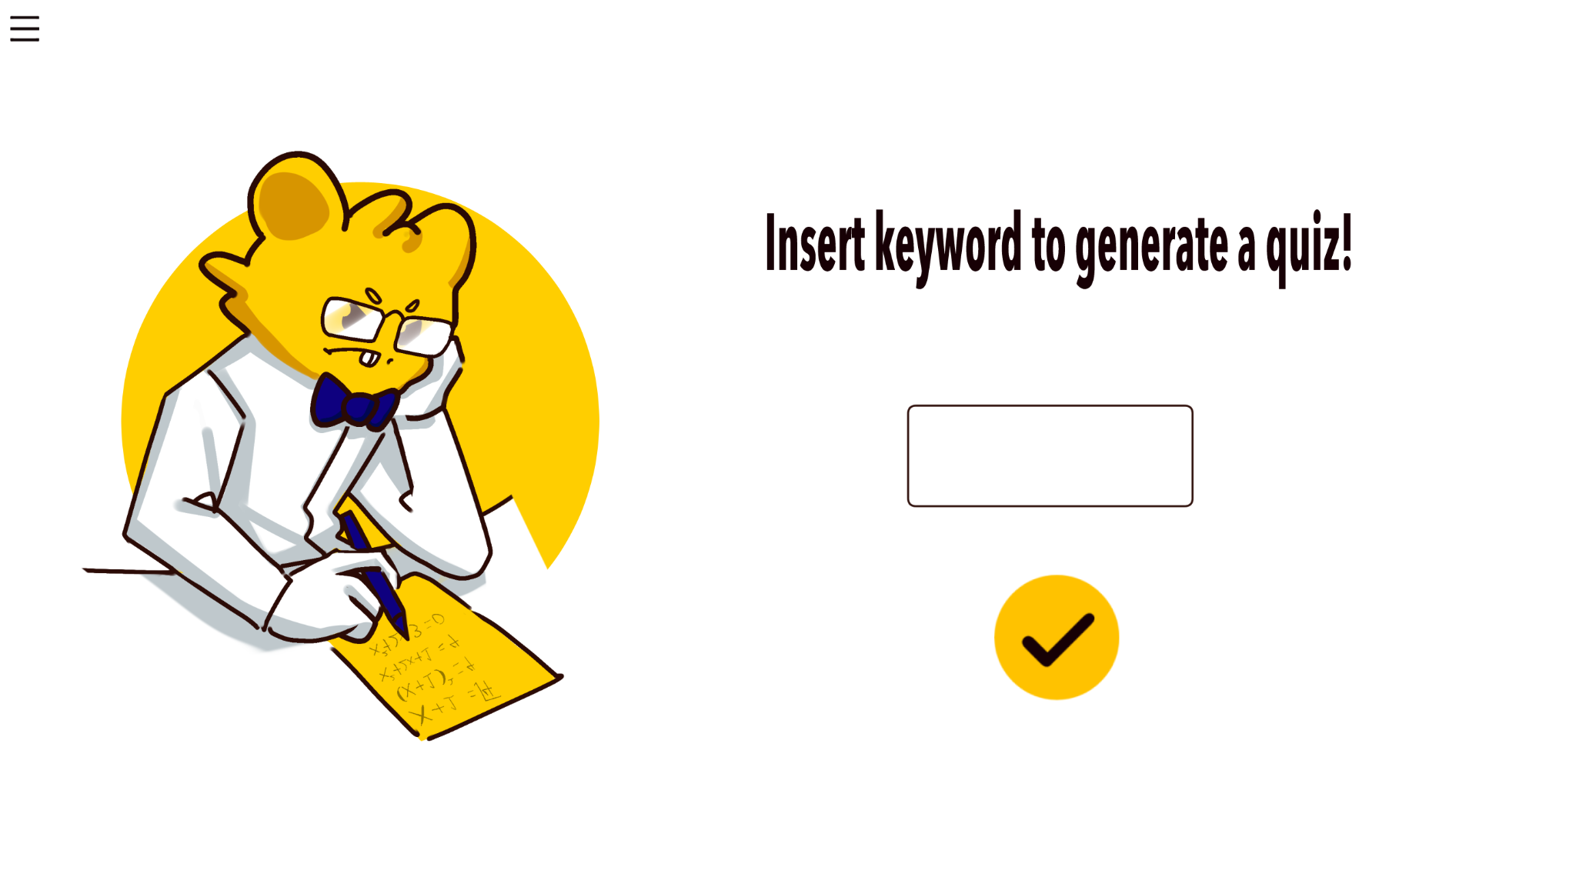

Figure 3.1.13

**3.2 Current Design:**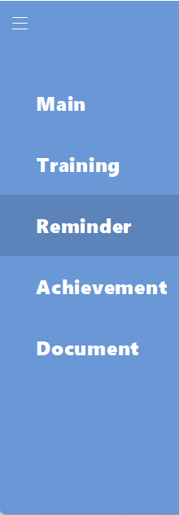

For the overall GUI in “LearningBuddy”, we use MainGUI as the main panel to show most interfaces. In MainGUI, including a jLayerPane to display multiple panels(including every function's interface). LayerPane allows panels having layers that cover lower level layers, in “LearningBuddy” MainGUI is setted to layer 2, and other functions are layer 3. A MenuPanel is used to select and display functions by clicking the button(panel). Giving a response with darker color while entering the panel area, letting the user know which button they are clicking(figure 3.2.1). MenuPanel is controlled by MenuToggleListener (interface method), it will make sure each method will be called to make the menu functionable(figure 3.2.2). 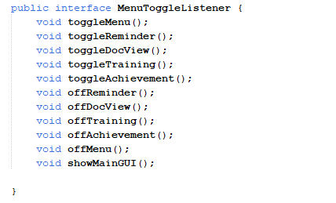

Figure 3.2.1

Figure 3.2.2 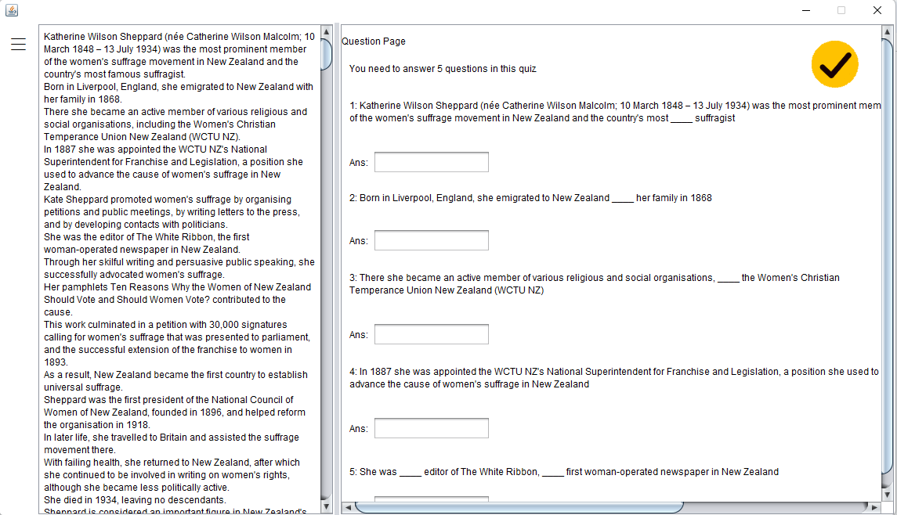

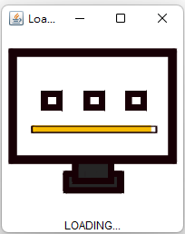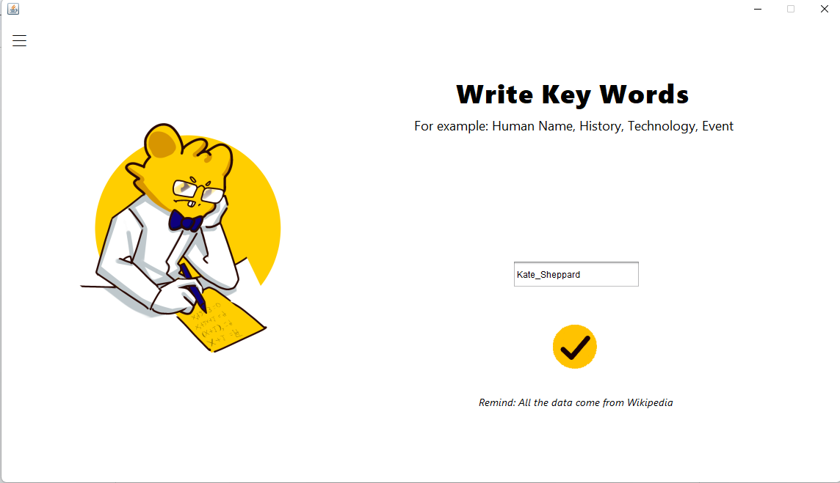

Figure 3.2.3 Figure 3.2.4 Figure 3.2.5

The training interface includes a layerPanel for displaying the quiz part, by setting the higher layer, and setVisible is true. A search button is given to search the key word that user input in a TextField, it will first pass the code that shows in figure 3.2.6, a JFrame appears for loading the data and close (setVisible as false) (figure 3.2.4). The question part will show(setVisible as True) (figure 3.2.5), and cover the request input page (higher layer). In figure 3.2.5, the quiz part has two ScrollPanels for separate usage. Left one is a passage that is related to the key words, and displayed on a TextArea. Right one is the questions, which have TextLabels and TextFields. A button is able to click and check answers, and bring back a request key word page by setting quiz panel setVisible as false.

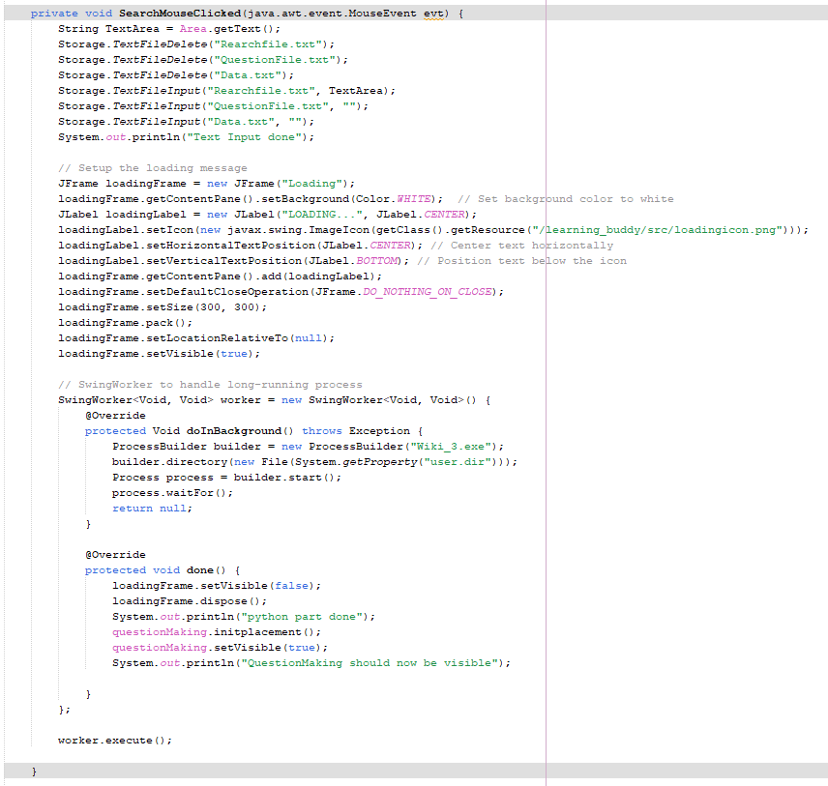

Figure 3.2.6

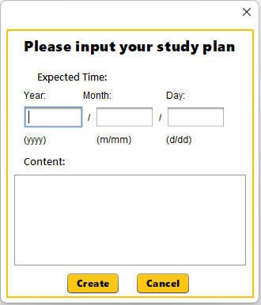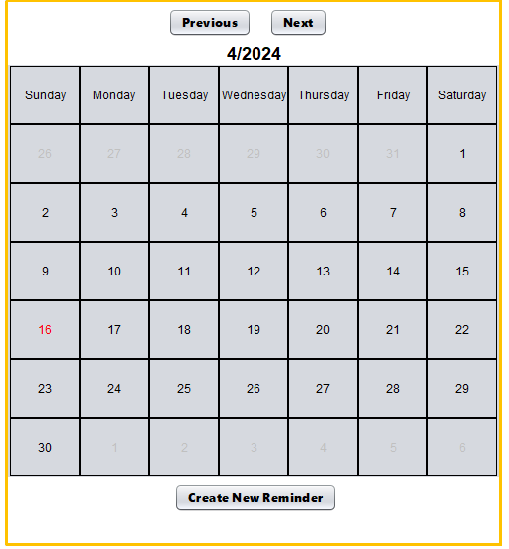

Figure 3.2.7 Figure 3.2.8

Reminder, having two main structures, calendar, and creating new reminders. Figure 3.2.7 is a calendar build with multiple reactable panel buttons, including 3 buttons with different usage. Figure 3.2.8, is a jFrame panel, having 3 Text Fields and 1 TextArea. 3 Text Fields are limited to input, Year only input 4 digit of number, Month and Day are 2 (figure 3.2.9). Two buttons allow the user to create a reminder and close to the create section.

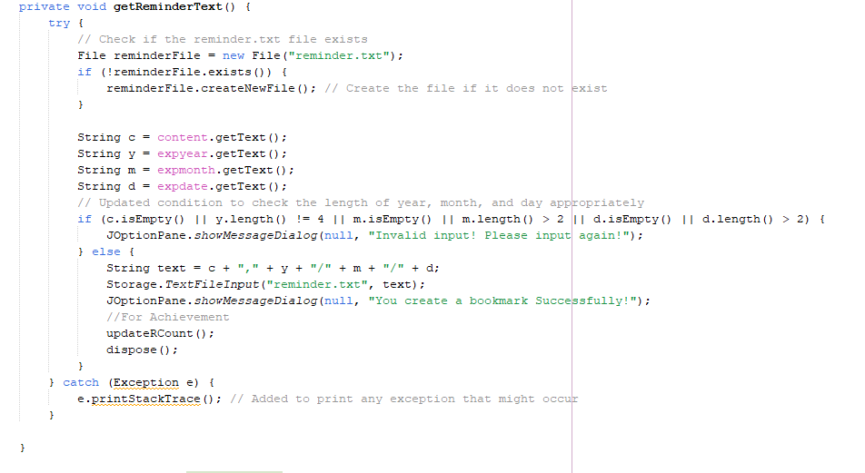

Figure 3.2.9

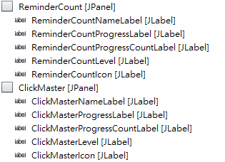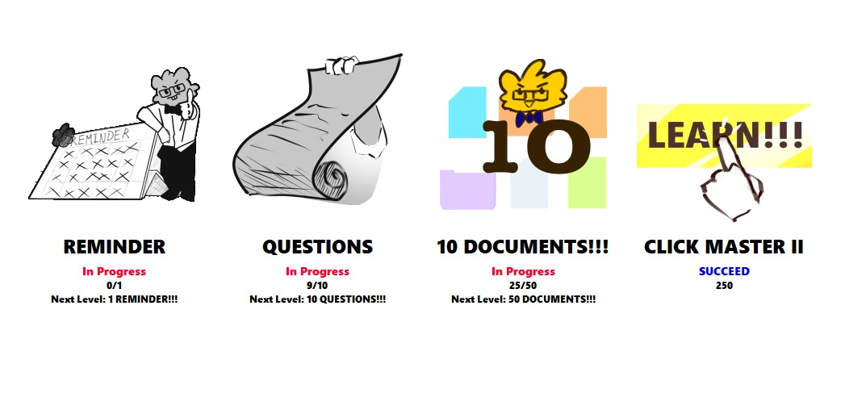

Figure 3.2.10 Figure 3.2.11

In Achievement, each achievement has 5 JLabels, for displaying the current progress. As you can see in figure 3.2.10 and 3.2.11, XXIcon is showing the corresponding achievement image base on which level it is, XXNameLabel is their name, XXProgressLabel is showing is the achievement the highest level or not, XXProgressCountLabel is show how many times left to next level, XXLevel is showing what the next level. In the current CLICK MASTER case, it is the highest level now, ClickMasterProgressCountLabel will only show overall count, ClickMasterIcon will change to golden image, ClickMasterProgressLabel is showing “SUCCEED” in blue, and ClickMasterLevel will be blank. in other case like ReminderCount, since it is not started/not reach level one, the ReminderCountIcon is setted as black and white, and it ProgressLabel show “In Progress” in red, ReminderCountLevel will show what the next level name.



Figure 3.2.12

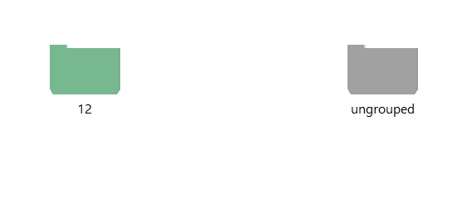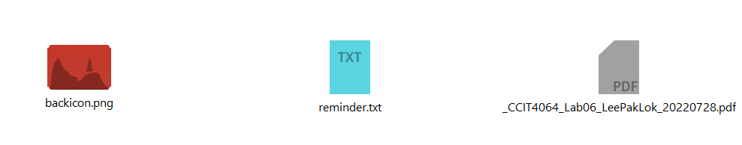

Figure 3.2.13 Figure 3.2.14

Lastly, Document Manager. There are multiple button to interact,

like the backIcon can return to the main page in Figure 3.2.13

Document Manager (figure 3.2.13). A menu button(figure 3.2.14) is placed on the bottom left, clicking it will pop up a menu(figure 3.2.15) to access different features in Document Manager.



Document Manager also features a tab system for opening files(figure 3.2.12). By double Figure 3.2.14

double clicking the existing files will open them in .pdf or .txt form (figure 3.2.13/ 3.2.14). 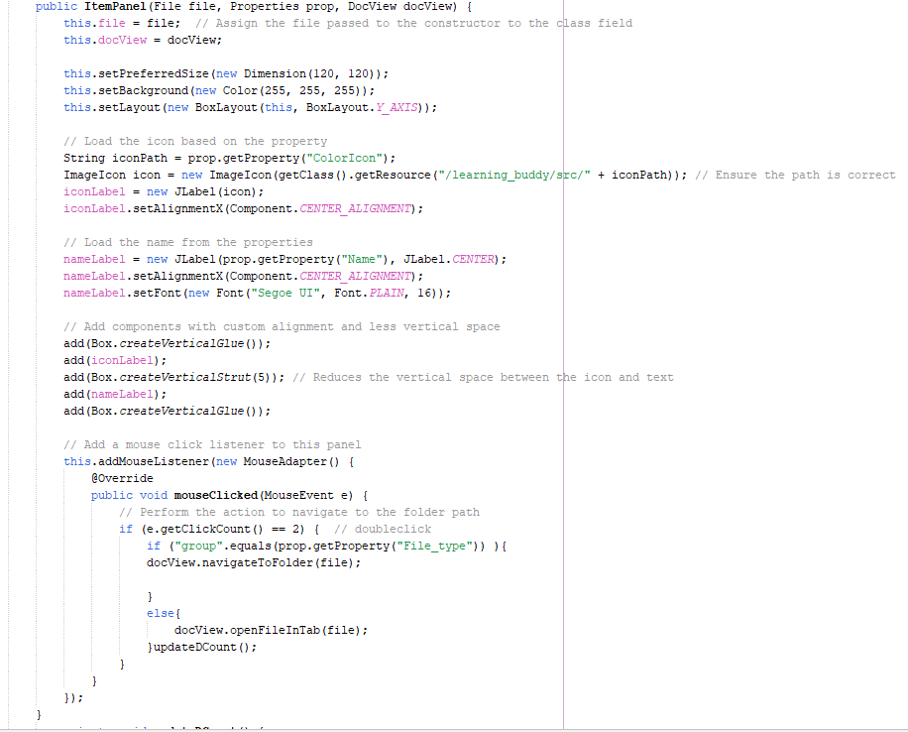

For displaying the imported item, a itemPanel method (figure 3.2.15) is used to place the item on a gridLayer ScrollPane.

Figure 3.2.15

**Resources Used:**

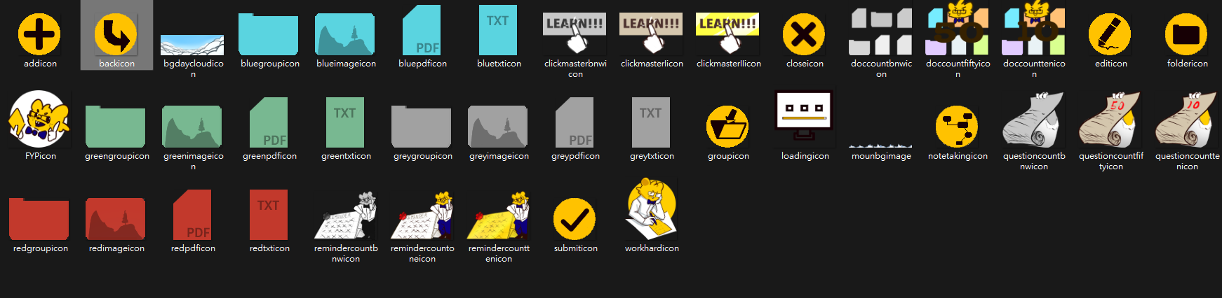

Figure 3.2.16

Figure 3.2.16 are the images created for this project. Including our LearningBuddy mascot: Neo, visualize achievement, buttons icon, files icon in different file types form and color, background…

**4. Methodology and Implementation**

**Login page:**

Document: Login.java

The Login function can let the user login in their account.

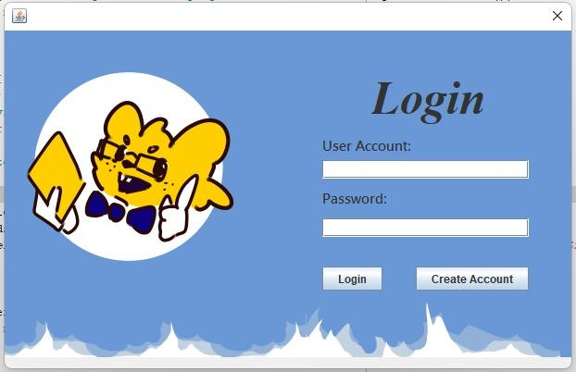

**Figure 4.1: The GUI of Main page**

In the login page, there are two buttons, which are “Login” and “Create Account”

Figure: The GUI of Create Account.

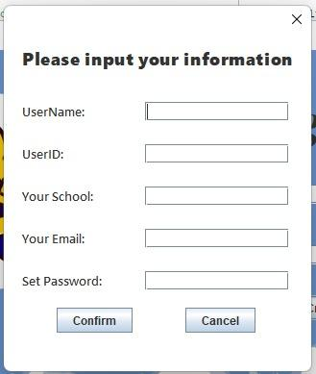

**Figure 4.2:New Login Create Account UI**

User can input his/her information to create his/her own account. All the information will store in the **Account.txt**

**Main Page:**

Document: Learning_Buddy.java

About the UI design:

Figure:

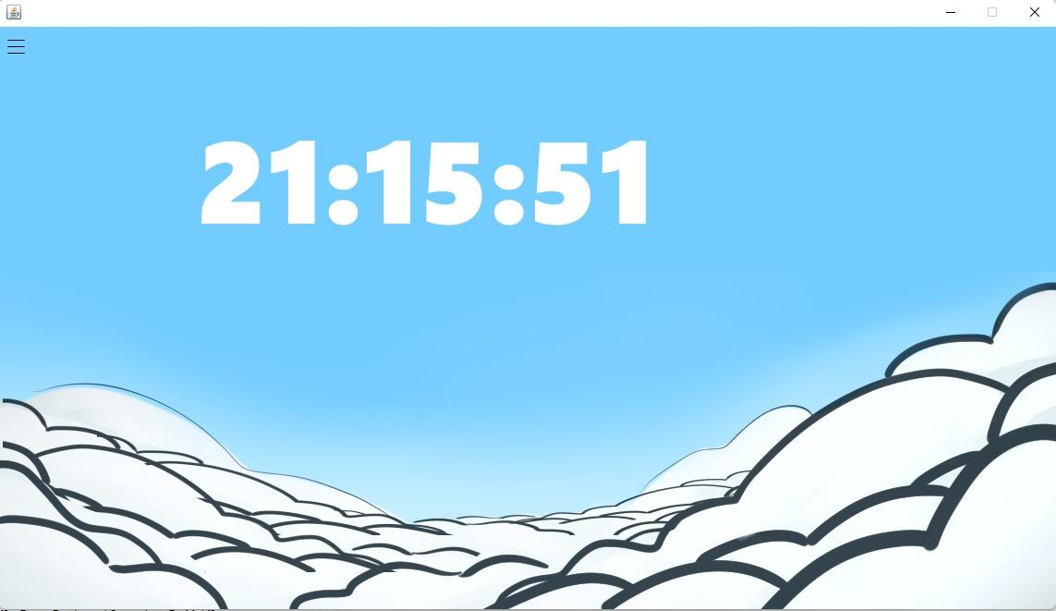

Figure 4.3:The Main page UI

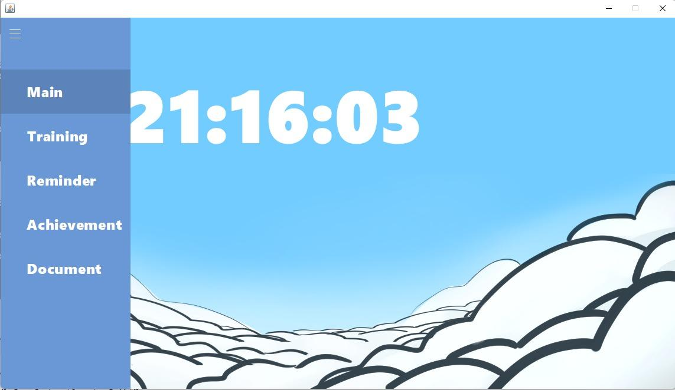

Figure 4.4:Menu of Main page

In our main page’s GUI, which includes an exquisite clock and pop-up menu, users can through the button to open/close the menu. Also, through the menu, users can jump to different functions.

**Reminder:**

Document: Reminder.java and LearnCalendar.java.

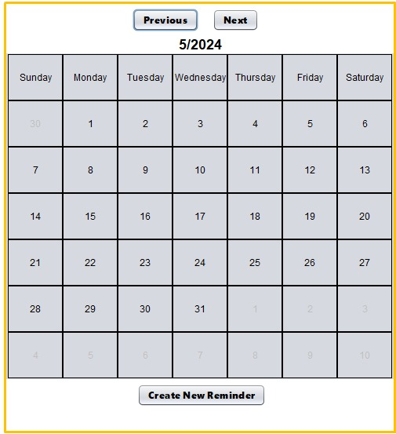

Figure 4.5: Calendar in Reminder function

The program will create a calendar showing the assigned study plan. Users can change the calendar to previous and next month with two buttons. When the next or previous button is clicked, the program will remove the created calendar and then create a new calendar which shows the next or previous month. In this function, users can input their study plan such as study target and expected time to finish by clicking the “Create New Reminder” button. The program will record their plan into reminder.txt file. After that, the program will check and create a bookmark by reading the information in the reminder.txt.

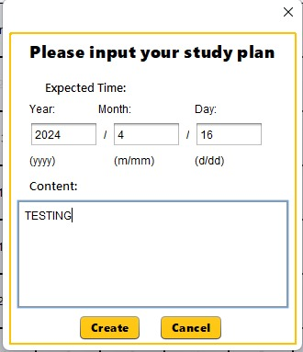

Figure 4.6: Create new plan

By reading the information in the reminder.txt, the date in the current month with created events or plans is in red color and others without any plan is in black. Users can click on the date with created plans and the plans for that day will show up.

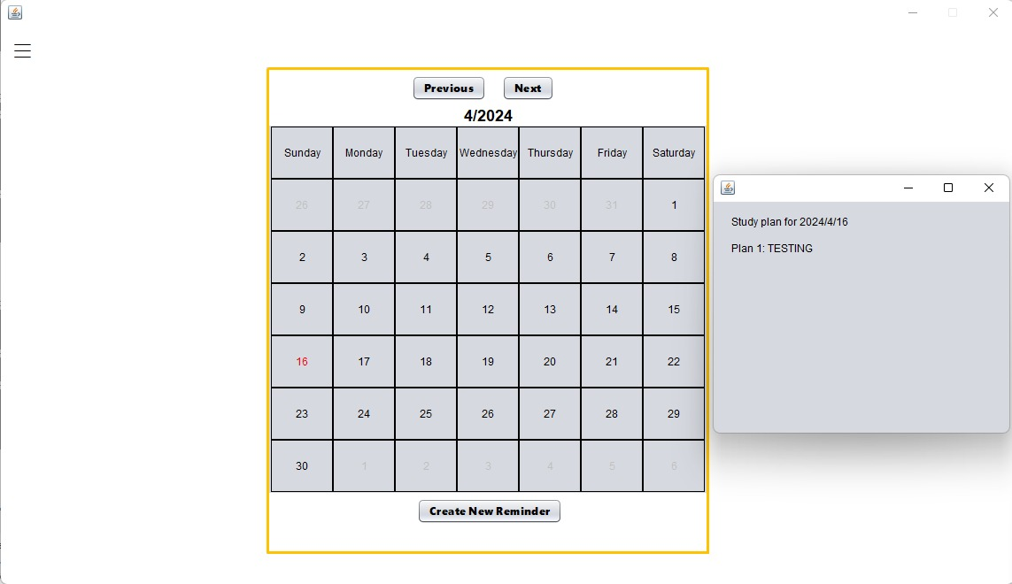

Figure 4.7

**Document Manager:**

There are three parts in the document manager: notes importing with files converting, notes grouping, notes and group property editing. Once the user clicks on the button to this function, the folders and notes in the Learning Buddy will be displayed. In the bottom right corner, the button to the four parts is displayed. For notes import, the user needs to choose the pdf/ txt/jpg/png file they wanted to import in the file chooser. 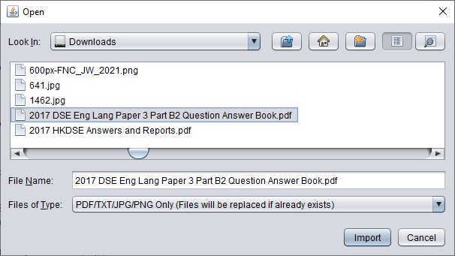

Figure 4.8

After clicking the import button, the selected file will be copied to Learning Buddy’s notes directory, within the ungrouped folder. The .properties file for the note will also be created, recording the file type, file path etc of it. If the selected file is a .jpg/ .png image, it will be converted to pdf automatically before the import process.

Figure 4.9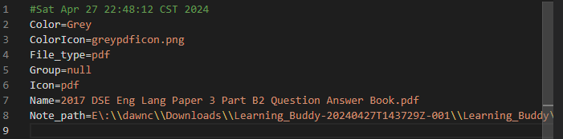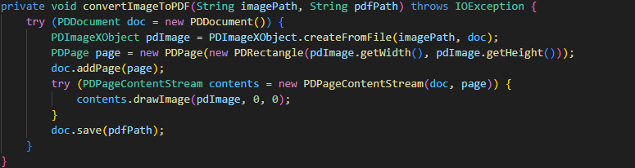

Figure 4.10

The note will then be displayed in the Learning Buddy.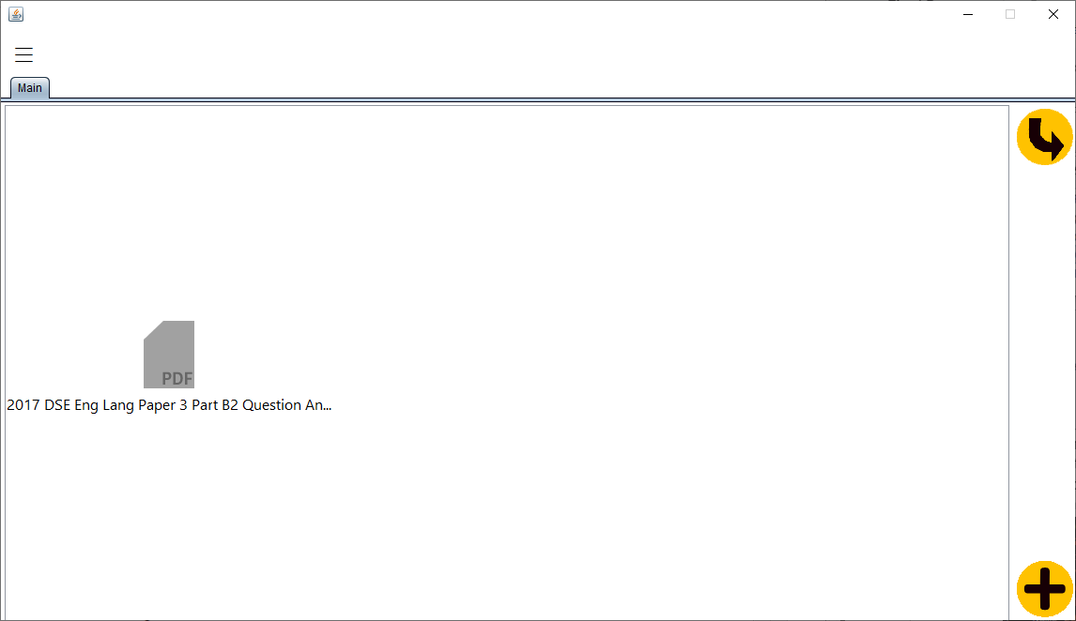

Figure 4.11

For notes grouping, the user needs to choose the property file of the note first. Then, the group name which user wanted to move the note to needs to be input. If the group does not exist, it will be created with a property file.

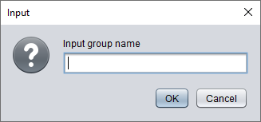

Figure 4.12

The group will be shown in the main page of the document manager.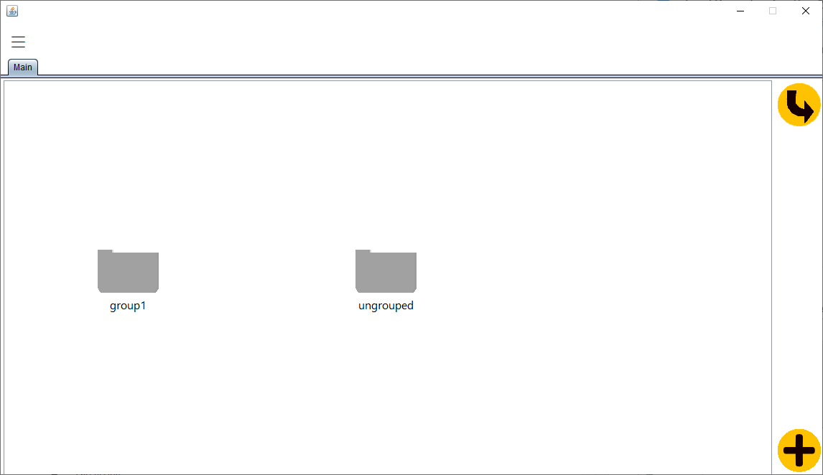

Figure 4.13

For note/ group property editing, the user needs to choose the property file of the note/ group first. Then the user can choose which property to edit.

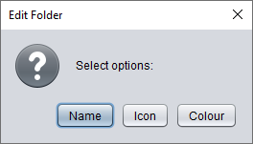

Figure 4.14

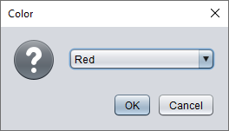

Figure 4.15

For example, setting the colour property of group1 to red will turn the icon of it to be red in the Learning Buddy.

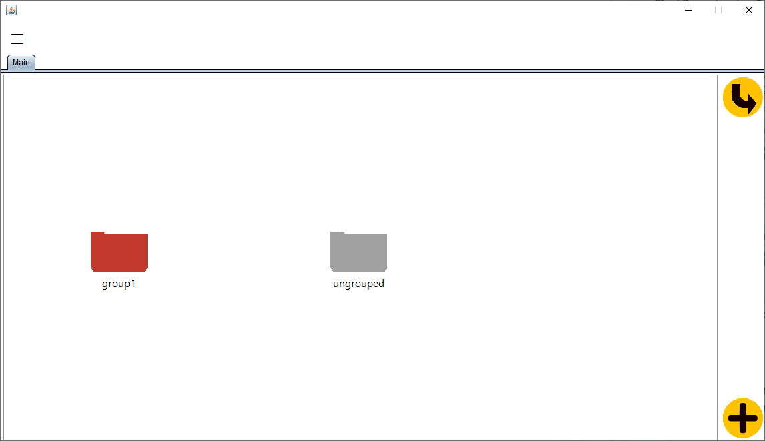

Figure 4.16

Document Manager also allows users to open their .pdf and .txt files inside the LearningBuddy. By double clicking an icon, the corresponding file will be opened. It will appear in the tab menu, and open that tab. All .pdf related features are using PDFBox 3.0 to fulfill.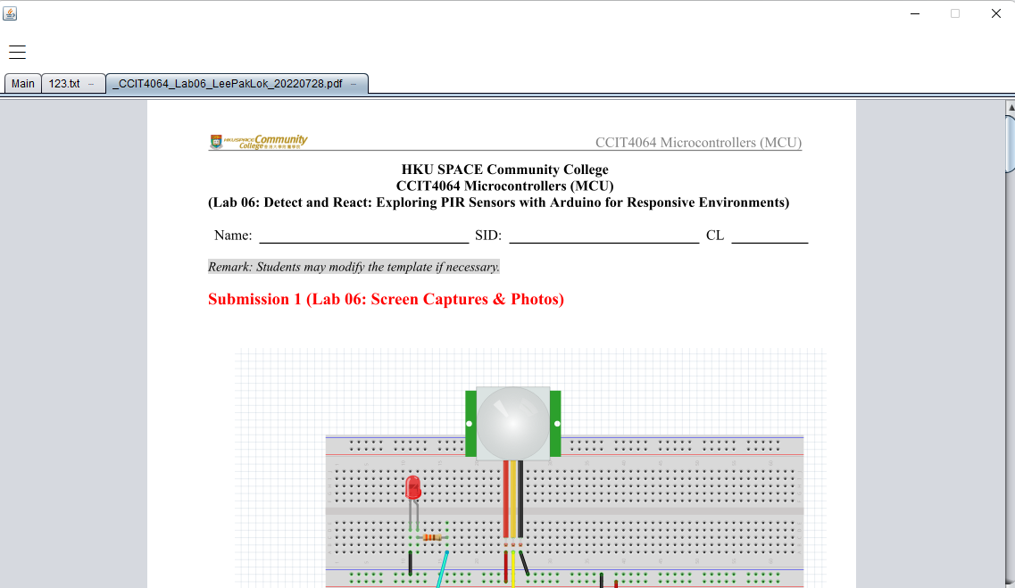

Figure 4.17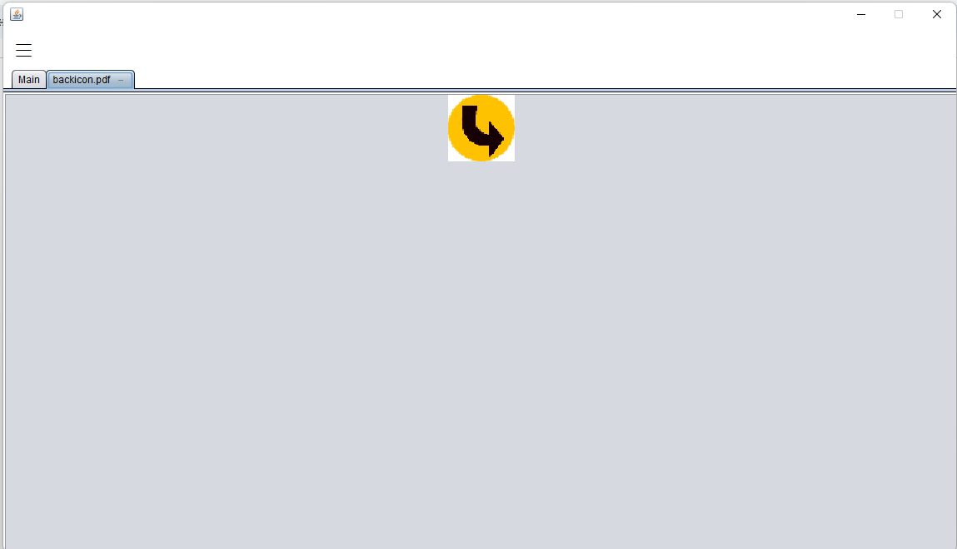

Figure 4.18

**Training:**

Document: Training.java, QuestionMaking.java, Wiki_3.exe and storage.java

In the Training function, we have two parts, which are the data collecting part and question making part. Users can through the above functions to make a quiz according to the provided keyword.

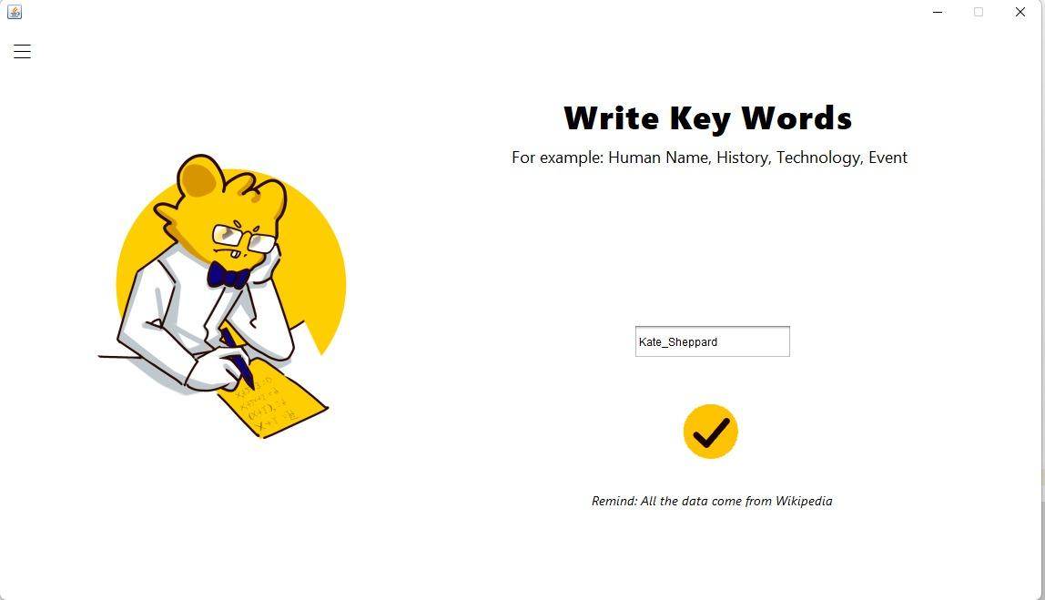

Figure 4.19

***Start:***

When the user enters the keywords, the program will search the information from wikipedia. In this part, the program will use the python program to acquire the information and deal with the information (Wiki_3.exe).

In this part, we use the python module Wikipediaapi to collect the data from Wikipedia.

The code was used:

wiki_wiki = wikipediaapi.Wikipedia("WikiSearcher (1704935142jian@gmail.com)",'en',extract_format = wikipediaapi.ExtractFormat.WIKI)

wiki_wiki = wikipediaapi.Wikipedia("WikiSearcher (1704935142jian@gmail.com)",'en',extract_format = wikipediaapi.ExtractFormat.WIKI)

Afterward, the program will do data clearing and create a quiz through a question making algorithm.

Remark: All the data will be stored at **data.txt and QuestionFile.txt**.

***For python part:***

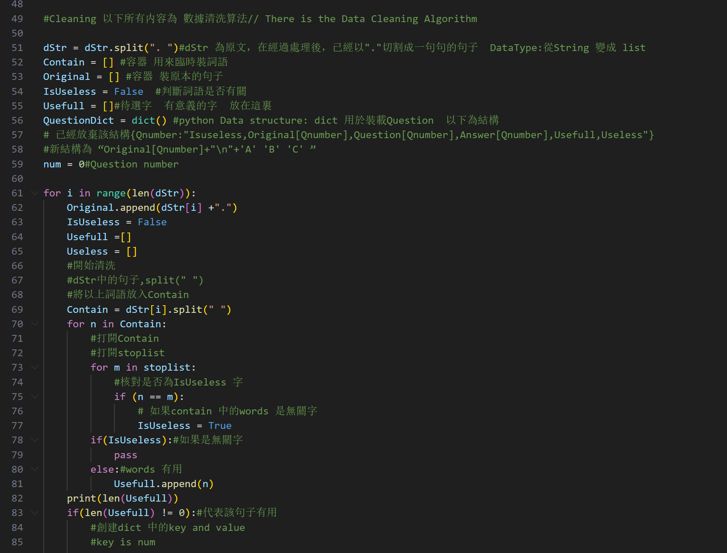

Figure 4.19

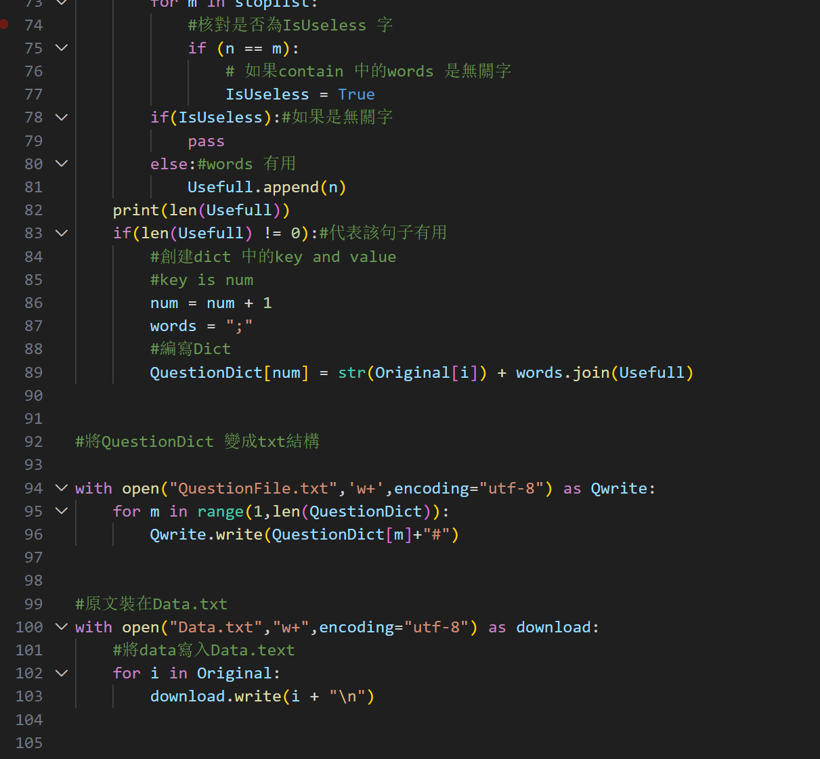Data clearing algorithm

Figure 4.20

About the algorithm:  
This algorithm aims to find out the useful words(which used to be the question)(according to the stoplist.txt) and split the data to be the completed sentence.(You can see the content of the stoplist.txt and output data in the appendices)  
After the program completed the data collecting part, the data will store into the QuestionFile.txt and Data.txt

Time complexity of Data clearing algorithm: f(n)=n3

***Here is the algorithm of question making:***

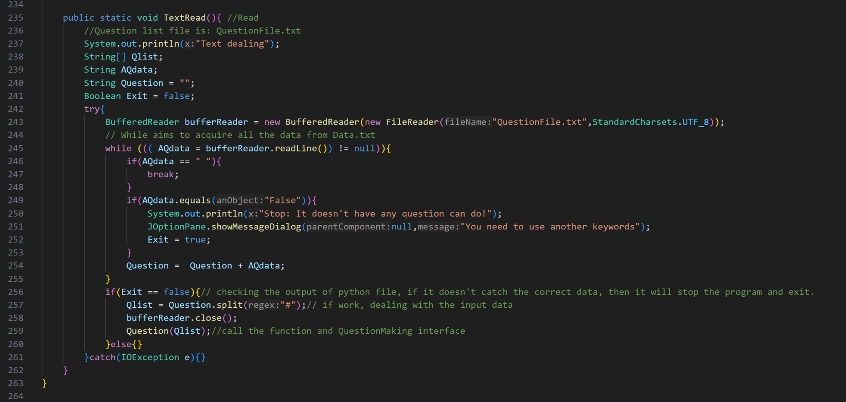

Figure 4.21

First, the program will follow the specific data structure to read the data, the program will split it and store the data into the String “Question”

Then, the program passes through the Qlist to the function Question.

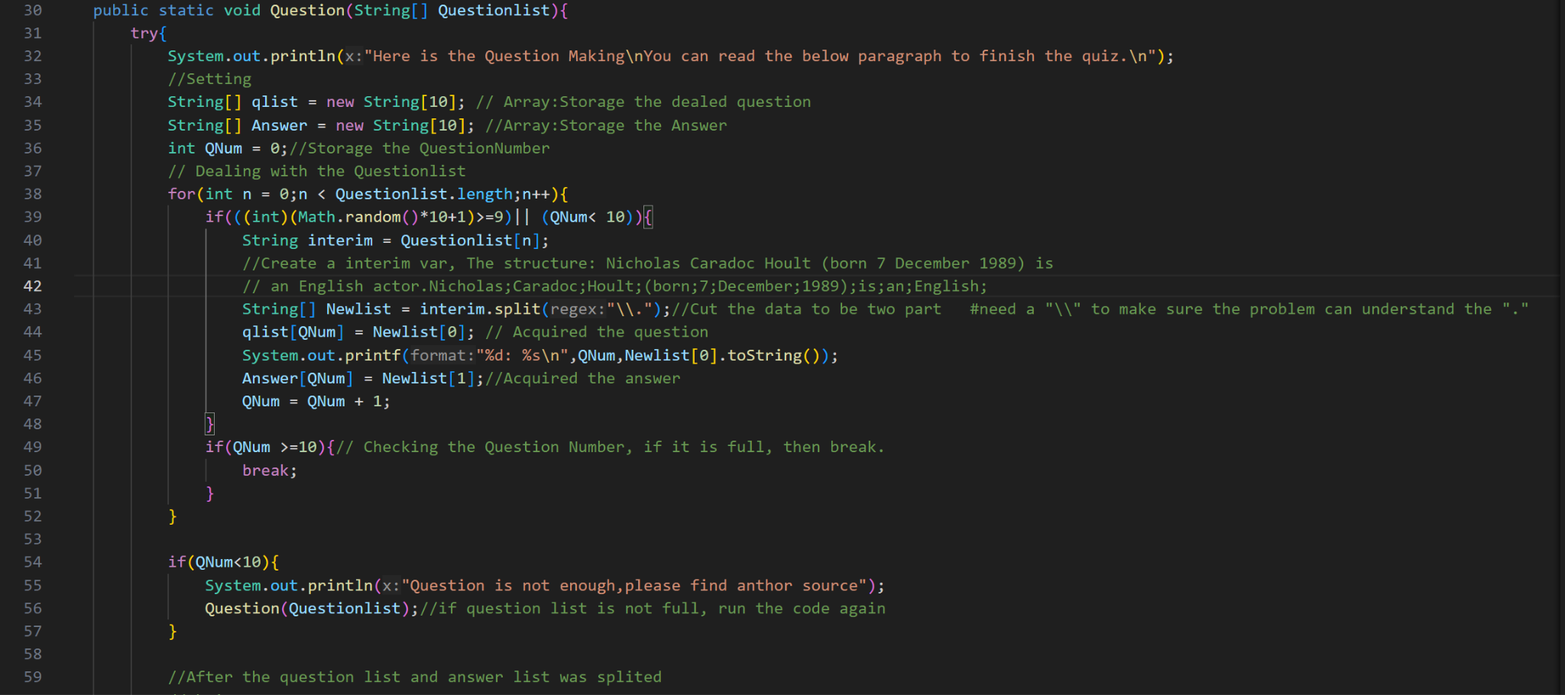

Figure 4.22

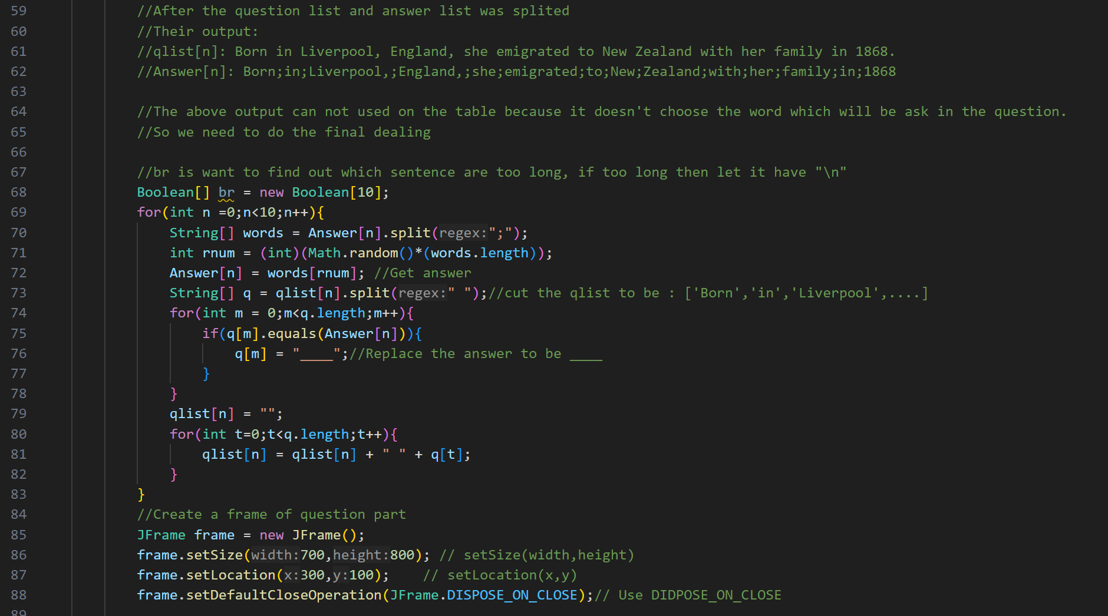

Figure 4.23 Time complexity: f(n)=n+n2

After the program finishes the question making part, the program will store the questions and answers in different variables. Next, the program creates the GUI of Training function.

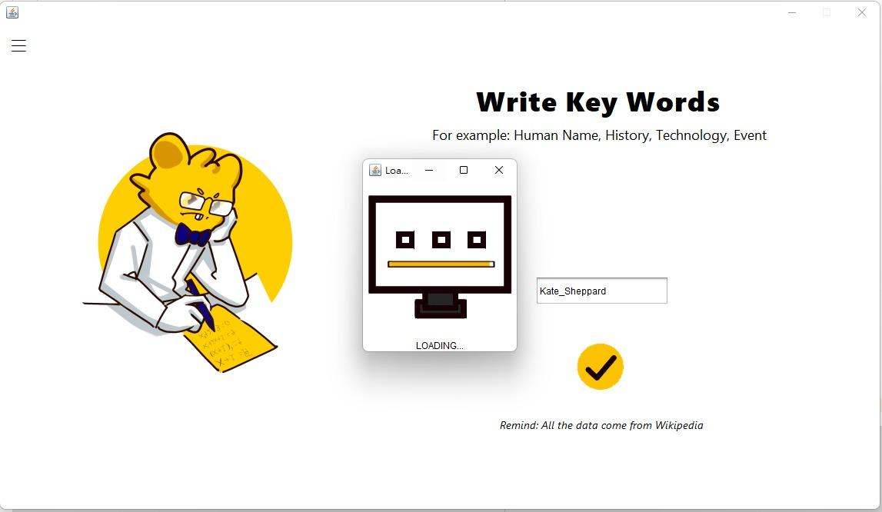

Figure 4.24

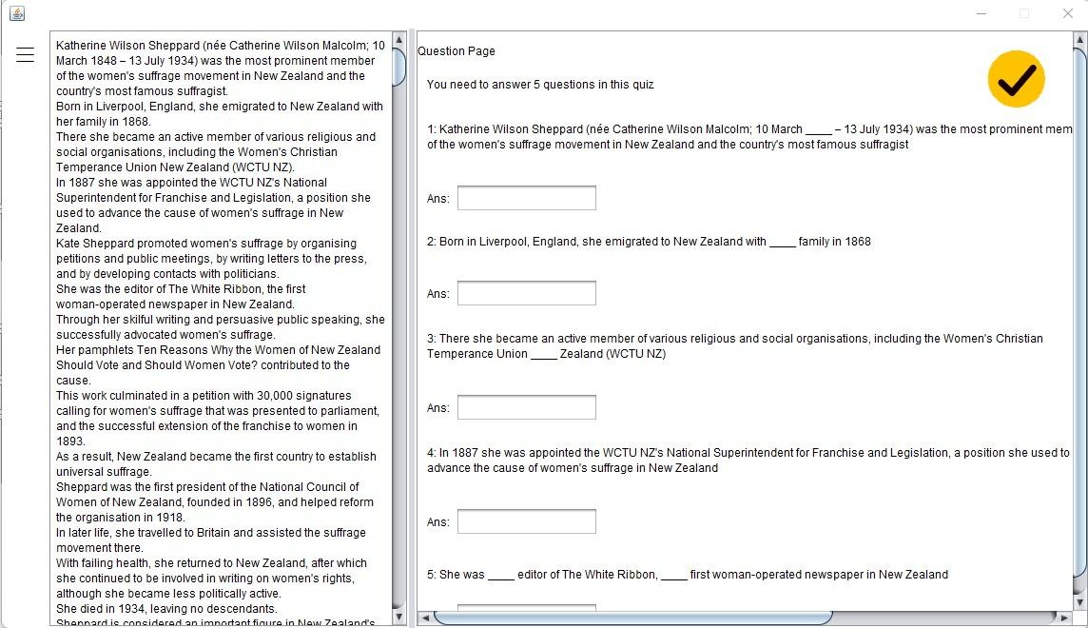

Figure 4.25: The quiz’s GUI.

A quiz of the key word is Kate_Sheppard.

The data text of the quiz will show near the quiz table(Right-hand side). Users can answer the question according to the text. All the user will spend a lot of time on reading the data, which make sure that they can acquire the knowledge successfully

After the user answers the question and clicks the Submit button, then the program will check all the answers and return the mark that their acquired.

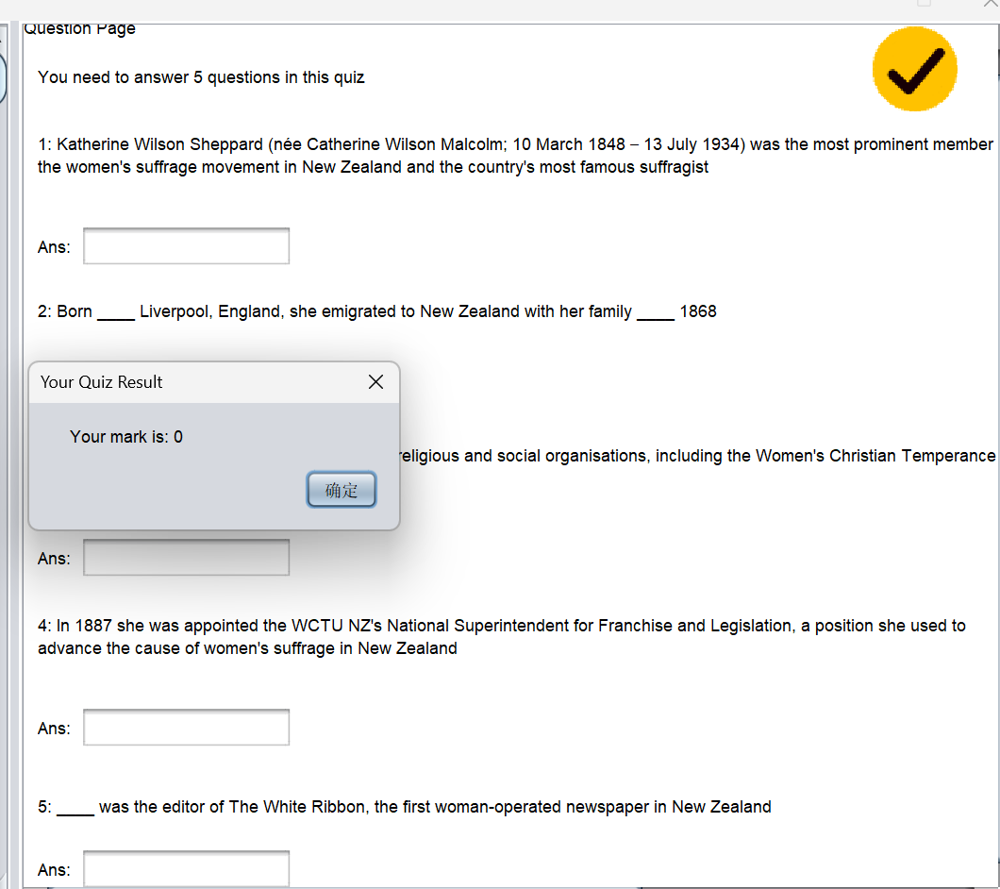

Figure 4.26: The result of click Submit button

**Achievement:**

Document: Achievement.java, all other java file with GUI displayed, AQCount.txt, RCount.txt, DCount.txt, clickCountFile.txt

Users can check their unlocked achievements here. There are 4 basic achievements in total and they have advanced achievements respectively. Different .txt files will be read in order to check whether users meet the requirement for unlocking certain achievements. Once these requirements are satisfied, corresponding achievements will be unlocked for them.

A “Refresh and Save” button is provided for users to refresh and save their unlocked achievements in a txt file which is located in the user's desktop.



Figure 4.27

Above is the image of the achievement GUI.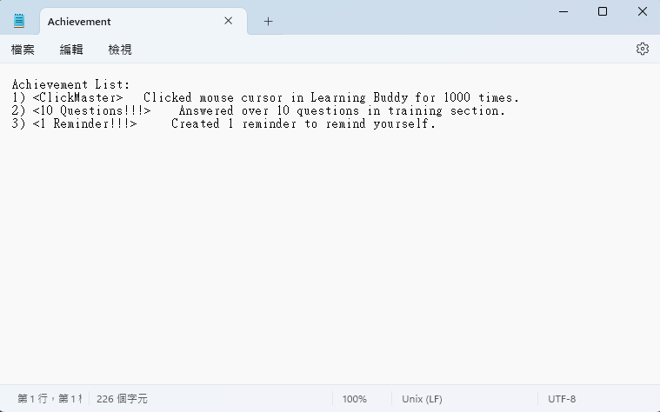

Figure 4.28

Above is the saved .txt file of the unlocked achievements.

It has been decided to use .properties for storing AQCount, RCount, DCount, clickCount data after fine tuning for better storage environment. Also, the achievement like Click Master will update the progress each time the software checks it has clicked, by using GlobalClick to check click action and calling getAch in Achievement class.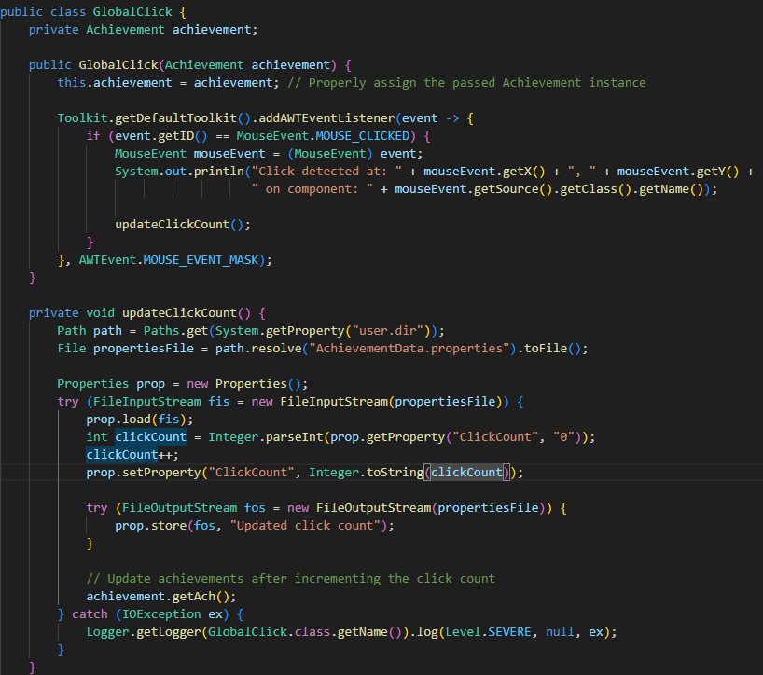

Figure 4.29

**Scheduling and Resources Allocation**

**Schedule**

**Table 2 Meeting Schedule**

| **DATE** | **Meeting** | **Description** | **Attending** |
| --- | --- | --- | --- |
| 1st (12-10-2023) | **Class Meeting** | We confirm that the topic of our project is “PDF Reader”(Amended Already) | Dawn, Bryan, Ben, Joe |
| 2nd (20-10-2023) | **Online** | Leo creates a discord group.  Ben does some setting in the github, Leo joins in it.  We decided to change the topic to “Learning Buddy”. | ALL |
| 3rd (25-10-2023) | **Online** | We discussed a short period plan about self learning, and some future aims. We will focus on our personal matters mainly. | Bryan, Ben, Leo, Joe |
| 4th (2-11-2023) | **Class** | We discuss the date of the next discussion and the ppt.  New idea: Learning assistant  Focus on convenience of student  E.g. Countdown timer, achievements(have prizes?), notes management, reminder | Dawn, Ben, Bryan |
| 5th(09/11/2023) | **Online** | We have finished our presentation powerpoint, and discussed Learning Buddy’s purposes and functions.  Learning Buddy – A study tool for students. | Bryan, Dawn, Ben, Leo, Joe |
| 6th(15/11/2023) | **Online** | Describe: We have to prepare for the presentation.  Rehearsal of presentation, adding Feasibility part to the proposal. | Bryan, Dawn, Ben, Leo |
| 7th(16/11/2023) | **Class** | We have a presentation.  JCH uploaded two java files in the github, there are “Learning Buddy.java” and “Login.java”. | Bryan, Dawn, Ben, Leo |
| 8th(7/12/2023) | **Online** | We prepare the presentation powerpoint.  We discussed the functions of our product again.  1. Reminder  2.Achievement System  3.Document Management  4.Training | Bryan, Joe, Ben, Leo |
| 9th(13-12-2023) | **Online** | We finished the ppt for the second presentation. | ALL |
| 10th(14-12-2023) | **Class** | We have a presentation. We decided to finish the basic part of the program on/before Christmas(24-25/12/2023). | ALL |
| 11th(18-1-2024) | **Online** | Discuss the future plan of the project.  JCH: Explain the recent plan. | ALL |
| 12th(20-1-2024) | **Online** | Do the interim report, discuss the project.  We share the idea about the function | Ben, Dawn, Bryan, Joe |
| 13th(26-1-2024) | **Online** | Complete the interim report and start making Powerpoint about the project progress presentation (semester 2 lesson 1). | ALL |
| 14th(31-1-2024) | **Online** | We finished the ppt and prepared for the presentation. Also, we added some new things in our interim report. | ALL |
| 15th(22-2-2024) | **Class** | We show our demo and discuss the recent schedule.  Also, Leo asks some questions about the new function.  Ben answers it and searches for some data to solve this problem. | Ben, Dawn, Bryan, Leo |
| 16th(7-3-2024) | **Class** | We amend some details of the program.  Ben:   * Amends the Login UI and the training function. * Determines the updated content, create the src file in the github account.   Joe   * share the progress of reminder * e.g. create a calendar for user   Bryan   * share the achievement list * plan to finish the .java   ALL: we determines the recent plan, which including：   * Finish the function writing * Design the ICON * 4 for the function * Cut some design and function * Learn new knowledge about the java netbeans * give up the UI design of the main function (Because of the huge workload) | Ben, Joe, Bryan |
| 17th(21-3-2024) | **Class** | We debug the program.  such as the reminder.java and achievement.java  Also, teacher checked our project demo and project progress | Ben, Dawn, Bryan |
| 18th(11-4-2024) | **Class** | We finished most of the function and plan to design a new GUI. | ALL |
| 19th(21-4-2024) | **Online** | We worked on the final report. | ALL |
| 20th(25-4-2024) | **Class** | We have a presentation on that day, we plan the next discussion day and try to finish the final report. | ALL |
| 21th(27-4-2024) | **Online** | “LearningBuddy” is completed. We write the final report and the ppt. Also, we do the final checking of our product. | ALL |

**Resource Allocation**

**Table 3 Resource Allocation**

| **Function** | **Responsible Person** |
| --- | --- |
| **Training** | **Jian Chun Hin, Ben** |
| **Reminder** | **Chau Siu Hong, Joe** |
| **Achievement** | **Lam Tsun Ting, Bryan** |
| **Document Manager** | **Chan Tze Hei, Dawn** |
| **Designer** | **Lee Pak Lok, Leo** |
| **Login Page** | **Jian Chun Hin** |
| **Main Page & Information Page** | **Jian Chun Hin** |
| **Software GUI & Fine Tuning** | **Lee Pak Lok, Leo** |

**Discussion**

**Difficulties**

As for this project, our group members have a variety of concerns about our project, like the function of different parts. In the Training part, it is a significant function of our program, which can provide a quiz of the new knowledge. For this quiz creating function, we considered that we can use the AI - ChatGPT4.0 to fulfill our demand. However, when we started to study the feasibility, we found that there are 2 difficulties we faced.

First, ChatGPT 4.0 service wasn’t free. If we want to use it, we will have a gigantic budget for payment. Second, ChatGPT4.0 didn’t allow Hong Kong people to use it, which means that if we want to utilize it, we should have a VPN. Therefore, in order to solve the above problems, we decided to give up this idea thereafter. Instead of the method, we try to create a Algorithm to do the data clearing and question making, which can output a quiz according to the user's keywords.

Apart from the Training part, we also have some problems in other parts, likewise the achievement. For this part, our group members were concerned about how to accomplish a demand of sparking the different achievements. For this we have a complex discussion. In the end we decided to design all the achievement types first. Regarding the sparking method, they were inserted into the program after we finished the process of program development. Even though we waste too much time on it, we still successfully solve this problem.

When we started to do the login page, we found difficulties about the GUI. As we didn’t have much chance to apply the knowledge in OOP, lots of bugs occurred when we tried to implement it. So we spent some time doing revision of GUI and research for related knowledge. Luckily, we solved this problem in April and created a new UI design successfully.

Besides, we also have difficulty with resources from the internet, such as the python module and java’s jar document. As for the java’s jar document, we didn’t know how to use it in the primary period after we downloaded the file. However, when we study further, we succeed in using them.

**Conclusion** To sum up, our project has already finished the development plan, including the login page, main page, Reminder, Training, Document Manager and Achievement. After the quality testing, there are only a few bugs in our program but they don’t affect our demo seriously. Also, the program design fulfilled the initial demands of our project, all the users can utilize our program to acquire new knowledge. We evaluated that this project can be used in real-life situations and in the education field.

**Recommendations**:

1. Training Function:

-Users can provide the data for question making, the program doesn't need to connect to the internet to acquire the data.

-Further style of question, such as MC question, Long question.

-Improve the algorithm: Data Clearing and Question Making.  
 As for the data clearing, there still exist some unnecessary words in the dealed data

Regarding the question making algorithm, the question creating should be random

1. Achievement:

-Add more achievements, help users acquire more confidence in learning.

-Provide more awards, such as credit, which can be used to buy something.

1. Main page:

-Adding a dynamic background in the main page, increasing the artistry.

-Provided some music/BGM, creating a better environment for learning.

**Future Scope:**

Potential extension or improvements:

1. More functions can be added to enhance the learning efficiency.
2. Create an AI in our program, same as the Chat GPT, users can ask some questions to it, who will return the accurate answer.
3. Mobile apps can be created that users can learn in a more convenient way.
4. Think about the business model, consider the commercial plan
5. Scholar helper: Provide the article checking service, improve the content of the article.
6. Adding a cloud storage for Learning Buddy to sync user data such as notes, learning progress and achievements.

**Individual Progress**

**Table 4 Individual progress**

| Name | Job | Progress | Progress Percentage |
| --- | --- | --- | --- |
| **Jian Chun Hin, Ben** | Login(Done) | Constructure | 100% |
| InterfaceDesign | 100% |
| Learning Buddy (Done) | Constructure | 100% |
| InterfaceDesign | 100% |
| Training(Done) | Constructure | 100% |
| InterfaceDesign | 100% |
| Acquire Information | 100% |
| QuestionPart | 100% |
| **Chau Siu Hong, Joe** | Reminder | Constructure | 100% |
| InterfaceDesign | 100% |
| **Lam Tsun Ting, Bryan** | Achievement | Constructure | 100% |
| InterfaceDesign | 100% |
| **Chan Tze Hei, Dawn** | Document Management | Constructure | 100% |
| InterfaceDesign | 100% |
| **Lee Pak Lok, Leo** | Design | User Interface Concept Design | 100% |
| Graph/Material | 100% |
| InterfacePrototype | 100% |
| Fine-tuner | Fine Tune Whole Software (Code Logic… etc) | 100% |

**References**

1.Python module - Wikipediaapi

Link: <https://pypi.org/project/Wikipedia-API/>

Download Method: pip3 install wikipedia-api

Field: It was used in Training Function

Target: Collectting the data from Wikipedia

wiki_wiki = wikipediaapi.Wikipedia("WikiSearcher (1704935142jian@gmail.com)",'en',extract_format = wikipediaapi.ExtractFormat.WIKI)

2. PDFBox

Link: <https://pdfbox.apache.org/>

Field: It was used in Document Manager function

Target: All PDF file related features are using PDFBox 3.0 to fulfill.

**Appendices**

If you want to know more information, you can go to our Github page to acquire our product:<https://github.com/HKU-Space-Engineering/Group>

stoplist.txt:

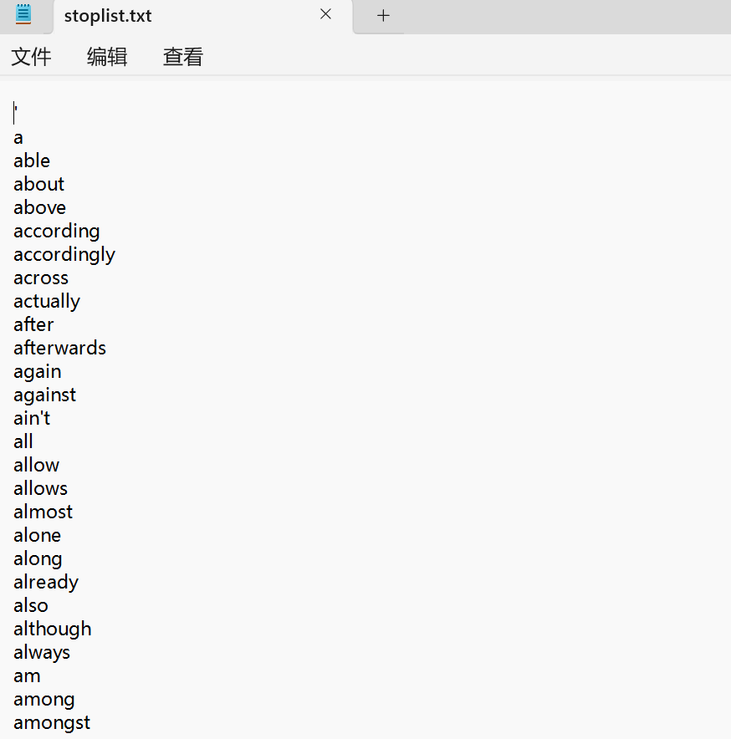

Rearchfile.txt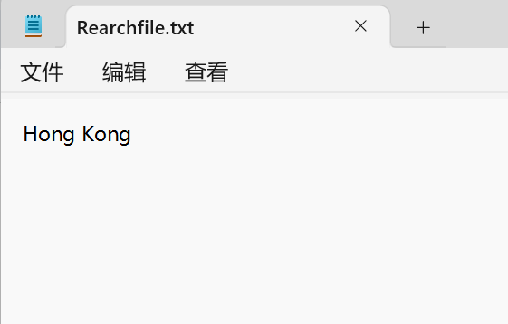

QuestionFile.txt

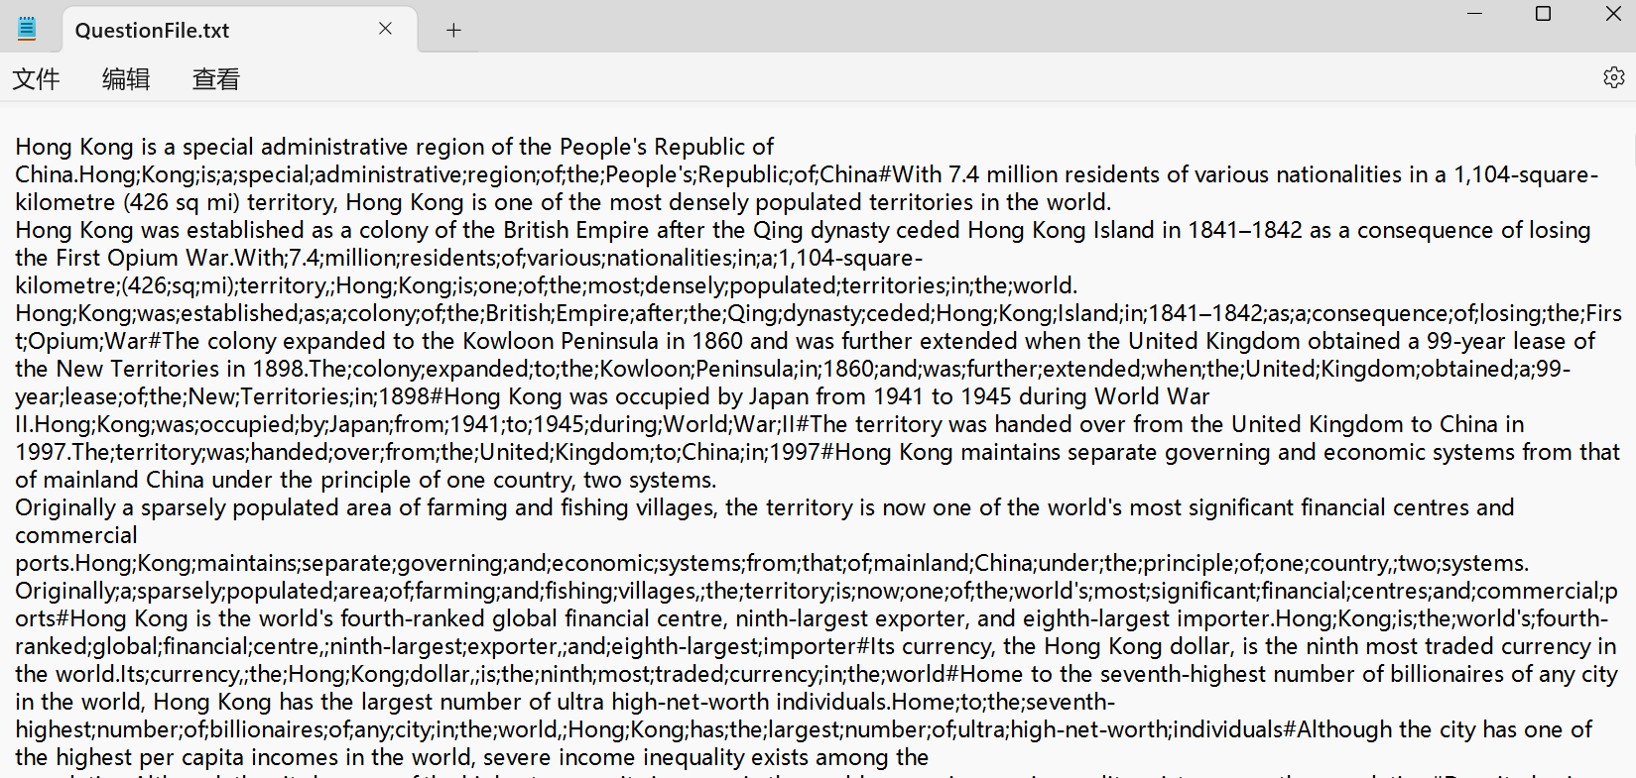

Data.txt

